Résumé
Ce projet de fin d'études a été réalisé au sein de Horizon Education dans le cadre du développement d'une solution éducative destinée aux jeunes enfants. L'objectif principal est de concevoir et de développer un jeu éducatif permettant d'initier les enfants aux concepts fondamentaux de l'Intelligence Artificielle à travers une série de mini-jeux interactifs et progressifs.
Le jeu est intégré à la plateforme éducative Ferid Around the World et couvre les principales étapes du développement d'un système d'Intelligence Artificielle, notamment la collecte des données, le nettoyage des données, la reconnaissance d'images, la détection de visages, le débogage des systèmes d'IA, la planification de trajectoires et la prise de décision. Chaque activité a été conçue selon une approche ludique afin de rendre ces notions accessibles aux jeunes apprenants.
Le projet a été développé avec le moteur de jeu Unity en utilisant le langage C#, tout en suivant la méthodologie Agile Scrum afin d'assurer une gestion itérative du développement. En complément des mini-jeux éducatifs, une fonctionnalité basée sur l'Intelligence Artificielle a été intégrée grâce à un modèle de reconnaissance vocale développé avec PyTorch et déployé dans Unity via Sentis, permettant au joueur de contrôler un robot à l'aide de commandes vocales en anglais.
Les résultats obtenus démontrent la faisabilité de l'intégration de concepts d'Intelligence Artificielle dans un environnement éducatif interactif adapté aux enfants. Cette application constitue une base évolutive pouvant être enrichie par de nouveaux contenus pédagogiques ainsi que par l'ajout du support multilingue et l'amélioration des performances du modèle de reconnaissance vocale.
Mots-clés : Intelligence Artificielle, Jeu éducatif, Unity, C#, Scrum, Apprentissage par le jeu, Reconnaissance vocale, Réseaux de neurones convolutifs, PyTorch.

Abstract
This Final-Year Project was carried out at Horizon Education with the objective of designing and developing an educational game that introduces young children to the fundamental concepts of Artificial Intelligence through interactive and engaging gameplay.
The developed game is integrated into the Ferid Around the World educational platform and is organized as a sequence of educational mini-games representing the main stages of the Artificial Intelligence development process, including data gathering, data cleaning, image recognition, face detection, AI system debugging, robot path planning, and decision making. Each activity was designed using age-appropriate interactions, visual feedback, and progressive learning mechanics to simplify complex AI concepts.
The application was developed using the Unity game engine and the C# programming language while following the Agile Scrum methodology to ensure iterative development and continuous integration. In addition to the educational gameplay, the project incorporates an Artificial Intelligence speech recognition module based on a Convolutional Neural Network (CNN) developed with PyTorch and deployed in Unity using Sentis. This module enables learners to control a virtual robot through English voice commands, providing practical exposure to a real AI application.
The obtained results demonstrate the effectiveness of combining educational games with Artificial Intelligence technologies to create an engaging learning environment for children. The developed solution provides a scalable foundation that can be extended through multilingual speech recognition, improved model performance, and additional educational activities covering more advanced AI concepts.
Keywords: Artificial Intelligence, Educational Game, Unity, C#, Scrum, Gamification, Speech Recognition, Convolutional Neural Network, PyTorch.

TABLE OF CONTENTS

Abstract .............................................................................................................. i
Acknowledgments ............................................................................................ ii
Table of Contents ............................................................................................ iii
List of Figures .................................................................................................. v
List of Tables .................................................................................................. vii
General Introduction ....................................................................................... 1
Chapter 1 General Project Context ............................................................... 2
Introduction ..................................................................................................... 3
1.1 Presentation of the Host Organization .................................................... 3
1.1.1 Horizon Education ........................................................................... 3
1.1.2 Ferid Around the World ................................................................... 4
1.2 Project Presentation ................................................................................ 5
1.2.1 Existing Solutions ............................................................................ 6
1.2.2 Problem Statement .......................................................................... 6
1.2.3 Proposed Solution ........................................................................... 7
1.3 Requirements Analysis ............................................................................. 7
1.3.1 Functional Requirements ................................................................. 8
1.3.2 Non-Functional Requirements ........................................................ 9
1.4 General Use Case Diagram ..................................................................... 10
Conclusion ..................................................................................................... 11
Chapter 2 System Architecture, Development Technologies and Project
Management Methodology ........................................................................... 12
Introduction ................................................................................................... 13
2.1 Game Architecture .................................................................................. 13
2.1.1 Overall System Architecture ........................................................... 13
2.1.2 AI Learning Architecture ................................................................. 14
2.2 Technologies Used ................................................................................. 15
2.2.1 Unity ............................................................................................... 15
2.2.2 C# .................................................................................................. 16
2.2.3 Visual Studio .................................................................................. 16
2.2.4 Krita ............................................................................................... 16
2.2.5 Git .................................................................................................. 17
2.2.6 GitHub ........................................................................................... 17
2.2.7 ClickUp .......................................................................................... 17
2.2.8 Slack .............................................................................................. 18
2.3 Project Management Methodology ......................................................... 18
2.3.1 Scrum Methodology ........................................................................ 18
2.3.2 Scrum Roles ................................................................................... 19
2.3.3 Scrum Artifacts ............................................................................... 20
2.3.4 Scrum Events ................................................................................ 21
2.3.5 Application of Scrum to the Project ............................................... 22
2.4 Product Backlog ...................................................................................... 22
2.5 Sprint Planning ....................................................................................... 23
2.6 Artificial Intelligence Module .................................................................. 24
2.6.1 Introduction ................................................................................... 24
2.6.2 Artificial Intelligence Domain ......................................................... 24
2.6.3 Deep Learning Model ..................................................................... 25
2.6.4 Model Selection ............................................................................. 26
2.6.5 Dataset Preparation ...................................................................... 27
2.6.6 Audio Preprocessing ...................................................................... 27
2.6.7 Model Training ............................................................................... 28
2.6.8 Integration with the Educational Application ................................ 29
2.6.9 Current Status and Future Enhancements ..................................... 30
Conclusion ..................................................................................................... 30
Chapter 3 Sprint 1 – Sprint 3 ....................................................................... 31
Introduction ................................................................................................... 32
3.1 Sprint 1: Data Gathering ......................................................................... 32
3.2 Sprint 2: Data Cleaning .......................................................................... 36
3.3 Sprint 3: Image Recognition Evaluation ................................................. 40
3.4 UML Modeling ......................................................................................... 44
3.4.1 Use Case Diagram .......................................................................... 44
3.4.2 Sequence Diagram ......................................................................... 45
3.4.3 Class Diagram ................................................................................ 46
Conclusion ..................................................................................................... 46
Chapter 4 Sprint 4 – Sprint 6 ....................................................................... 47
Introduction ................................................................................................... 48
4.1 Sprint 4: Face Detection ......................................................................... 48
4.2 Sprint 5: AI Agent Debugging ................................................................. 52
4.3 Sprint 6: Robot Path Planning ................................................................ 56
4.4 UML Modeling ......................................................................................... 60
4.4.1 Use Case Diagram .......................................................................... 60
4.4.2 Sequence Diagram ......................................................................... 61
4.4.3 Class Diagram ................................................................................ 62
Conclusion ..................................................................................................... 62
Chapter 5 Sprint 7 – Sprint 8 ....................................................................... 63
Introduction ................................................................................................... 64
5.1 Sprint 7: AI Decision Making ................................................................. 64
5.2 Sprint 8: Game Map ............................................................................... 68
5.3 UML Modeling ......................................................................................... 72
5.3.1 Use Case Diagram .......................................................................... 72
5.3.2 Sequence Diagram ......................................................................... 73
5.3.3 Class Diagram ................................................................................ 74
Conclusion ..................................................................................................... 75
General Conclusion ....................................................................................... 76
Webography…………………………………………………………………………77

LIST OF FIGURES

Figure 1.1 Horizon Education logo ............................................................... 4
Figure 1.2 Ferid Around the World Application ............................................ 5
Figure 1.3 General Use Case Diagram .......................................................... 10
Figure 2.1 Overall System Architecture ....................................................... 13
Figure 2.2 AI Learning Architecture ............................................................. 14
Figure 2.3 Unity Logo ................................................................................... 15
Figure 2.4 C# Logo ....................................................................................... 16
Figure 2.5 Visual Studio Logo ...................................................................... 16
Figure 2.6 Krita Logo .................................................................................... 16
Figure 2.7 Git Logo ....................................................................................... 17
Figure 2.8 GitHub Logo ................................................................................ 17
Figure 2.9 ClickUp Logo ............................................................................... 17
Figure 2.10 Slack Logo ................................................................................. 18
Figure 2.11 Artificial Intelligence hierarchy ................................................ 25
Figure 2.12 VoiceCNN Processing Architecture .......................................... 26
Figure 2.13 Audio Preprocessing Pipeline ................................................... 28
Figure 2.14 Model Training Workflow ........................................................ 29
Figure 2.15 Integration with Unity .............................................................. 30
Figure 3.1 Activity Workflow Data Gathering ............................................. 33
Figure 3.2 Data Gathering Tutorial .............................................................. 34
Figure 3.3 Data Gathering Gameplay .......................................................... 34
Figure 3.4 Correct Object Classification ...................................................... 35
Figure 3.5 Success Panel .............................................................................. 35
Figure 3.6 Activity Workflow Data Cleaning ............................................... 37
Figure 3.7 Data Cleaning Tutorial ............................................................... 38
Figure 3.8 Data Cleaning Gameplay ............................................................ 38
Figure 3.9 Wrong Classification ................................................................. 39
Figure 3.10 Activity Workflow Image Recognition ..................................... 41
Figure 3.11 Image Recognition Tutorial ...................................................... 42
Figure 3.12 Image Recognition Gameplay ................................................... 42
Figure 3.13 Evaluation Screen ..................................................................... 43
Figure 3.14 Use Case Diagram ..................................................................... 44
Figure 3.15 Sequence Diagram .................................................................... 45
Figure 3.16 Class Diagram ........................................................................... 46
Figure 4.1 Activity Workflow Face Detection .............................................. 49
Figure 4.2 Face Detection Gameplay ........................................................... 50
Figure 4.3 Evaluation Example .................................................................... 50
Figure 4.4 Correcting Robot's Answer ......................................................... 51
Figure 4.5 Activity Workflow AI Agent Debugging .................................... 53
Figure 4.6 AI Agent Debugging Gameplay .................................................. 54
Figure 4.7 Indicate Missed Agents .............................................................. 54
Figure 4.8 Agent Debugging Progress ......................................................... 55
Figure 4.9 Activity Workflow Robot Path Planning .................................... 57
Figure 4.10 Robot Path Planning Gameplay ............................................... 58
Figure 4.11 Placing Action Cards ................................................................ 58
Figure 4.12 Submit Selection ...................................................................... 59
Figure 4.13 Use Case Diagram ..................................................................... 60
Figure 4.14 Sequence Diagram .................................................................... 61
Figure 4.15 Class Diagram ........................................................................... 62
Figure 5.1 Activity Workflow AI Decision Making ..................................... 65
Figure 5.2 AI Decision Making Gameplay ................................................... 67
Figure 5.3 Action Cards Arrangement ......................................................... 67
Figure 5.4 Activity Workflow Game Map .................................................... 69
Figure 5.5 Locked and Unlocked Activities ................................................ 70
Figure 5.6 Locked and Unlocked Levels ...................................................... 70
Figure 5.7 Game Map Interface .................................................................. 71
Figure 5.8 Use Case Diagram ....................................................................... 72
Figure 5.9 Sequence Diagram ...................................................................... 73
Figure 5.10 Class Diagram ........................................................................... 74

LIST OF TABLES

Table 1.1 AI Learning Journey through Mini-Games .................................... 5
Table 1.2 Functional Requirements .............................................................. 8
Table 1.3 Non-Functional Requirements ...................................................... 9
Table 2.1 AI Learning Mapping Across Domains ......................................... 14
Table 2.2 Scrum Roles and Responsibilities ............................................... 20
Table 2.3 Product Backlog ........................................................................... 22
Table 2.4 Sprint Planning ............................................................................ 23
Table 2.5 Justification for Selecting CNN .................................................... 27
Table 2.6 Voice Command Categories ......................................................... 27
Table 3.1 Sprint 1 Backlog ........................................................................... 32
Table 3.2 Sprint 2 Backlog ........................................................................... 36
Table 3.3 Sprint 3 Backlog ........................................................................... 40
Table 4.1 Sprint 4 Backlog ........................................................................... 48
Table 4.2 Sprint 5 Backlog ........................................................................... 52
Table 4.3 Sprint 6 Backlog ........................................................................... 56
Table 5.1 Sprint 7 Backlog ........................................................................... 64
Table 5.2 Sprint 8 Backlog ........................................................................... 68

LIST OF ABBREVIATIONS

Abbreviation | Meaning
AI | Artificial Intelligence
ASR | Automatic Speech Recognition
CNN | Convolutional Neural Network
CPU | Central Processing Unit
FFT | Fast Fourier Transform
GUI | Graphical User Interface
IDE | Integrated Development Environment
LSTM | Long Short-Term Memory
ONNX | Open Neural Network Exchange
RNN | Recurrent Neural Network
UI | User Interface
UML | Unified Modeling Language

General Introduction

Artificial Intelligence (AI) has become one of the most influential technologies of the modern era, transforming numerous aspects of everyday life, including healthcare, transportation, communication, and education. As intelligent systems become increasingly integrated into society, understanding the fundamental principles of Artificial Intelligence is becoming an essential skill for future generations. However, most educational resources dedicated to AI are designed for older learners and often require programming knowledge or mathematical concepts that are difficult for young children to understand.
Educational games have emerged as an effective solution for simplifying complex concepts by combining learning with interactive and engaging activities. Through gamification, children can acquire knowledge naturally by experimenting, solving problems, and receiving immediate feedback. This pedagogical approach increases motivation while improving understanding and knowledge retention.
This Final-Year Project was carried out at Horizon Education, an educational technology company specializing in the development of digital learning solutions for children. The objective of the project is to design and develop an educational game that introduces children to the fundamental concepts of Artificial Intelligence through a series of interactive mini-games. The developed game is integrated into the Ferid Around the World educational platform and guides learners through the main stages involved in building an intelligent system, including data gathering, data cleaning, image recognition, face detection, AI system debugging, robot path planning, and decision making.
Beyond the educational gameplay, the project also integrates a real Artificial Intelligence component based on speech recognition. A Convolutional Neural Network (CNN) developed using the PyTorch framework enables learners to interact with the application through English voice commands, providing practical exposure to an authentic AI technology while enriching the learning experience.
From a software engineering perspective, the project follows the Agile Scrum methodology, enabling iterative development, continuous testing, and progressive integration of new functionalities. The application was developed using Unity and C#, while additional technologies such as GitHub, ClickUp, Slack, and Visual Studio supported version control, project management, collaboration, and software development throughout the internship.
This report is organized into five chapters. The first chapter presents the general context of the project, the host organization, the problem statement, the proposed solution, and the requirements analysis. The second chapter describes the system architecture, the development technologies, the project management methodology, and the Artificial Intelligence module integrated into the application. The third, fourth, and fifth chapters present the analysis, design, implementation, and UML modeling of the different educational mini-games developed during the successive Scrum sprints. Finally, the report concludes with an overall assessment of the project, the achieved results, and perspectives for future improvements.

Chapter 1

General Project Context

Introduction
Artificial Intelligence has become an essential technology in many aspects of everyday life, influencing how people communicate, learn, and solve problems. As AI continues to shape modern society, introducing its fundamental concepts at an early age has become increasingly important. However, most educational resources explain AI using technical terminology or programming concepts that are difficult for young children to understand.
Educational games provide an effective alternative by transforming abstract concepts into interactive experiences that promote exploration and active learning. Within this context, Horizon Education aims to enrich its educational platform by integrating innovative learning modules adapted to children's cognitive abilities.
This chapter presents the general context of the project. It begins with an overview of the host organization and its educational platform, followed by the presentation of the project, an analysis of existing educational solutions, the identified problem, and the proposed solution.

  - Presentation of the Host Organization
1.1.1 Horizon Education
The internship was conducted at Horizon Education, an educational technology company specialized in the development of interactive digital learning solutions for children. The company designs educational applications that combine modern technologies with pedagogical approaches to create engaging learning experiences.
Its activities focus on the development of serious games, educational mobile applications, interactive multimedia content, and digital learning platforms. By combining software engineering, game development, and educational design, Horizon Education seeks to make learning more engaging while encouraging curiosity, creativity, and critical thinking.
The company follows a learner-centered approach in which educational objectives are integrated into enjoyable and interactive experiences. This approach allows children to acquire new knowledge through exploration, experimentation, and problem-solving instead of relying solely on traditional teaching methods.

Figure 1.1. Horizon Education logo.
The company emblem used by Horizon Education across its products and communications.

1.1.2 Ferid Around the World
One of Horizon Education's flagship products is Ferid Around the World, an educational mobile application designed specifically for young children. The application serves as a digital learning platform that offers a collection of educational games and interactive activities covering multiple learning domains.
Rather than focusing on a single subject, the application introduces children to diverse topics such as mathematics, languages, science, geography, culture, environmental awareness, and life skills. Each activity is presented through colorful graphics, animations, voice guidance, and interactive gameplay adapted to children's age and learning pace.
The modular architecture of the application allows new educational content to be integrated continuously. This flexibility enables Horizon Education to expand the platform with additional learning experiences while maintaining a consistent user interface and educational methodology.
The project developed during this internship represents one of these educational modules. It extends the Ferid Around the World application by introducing a new learning experience dedicated to Artificial Intelligence, allowing children to discover AI concepts through interactive gameplay.

Figure 1.2. Ferid Around the World Application
The Ferid Around the World app icon, showing the robot mascot Ferid who guides learners through the platform.

1.2. Project Presentation
Artificial Intelligence is becoming an increasingly important part of everyday life, yet children rarely have access to educational resources that explain how intelligent systems work. Existing learning materials are generally designed for older students and often require programming knowledge or mathematical background.
The objective of this project is to develop a serious educational game that introduces children to the fundamental concepts of Artificial Intelligence through interactive mini-games. Instead of presenting theoretical explanations, the application enables children to learn by performing simplified AI-related tasks.
The game is integrated into the Ferid Around the World platform as a new educational module. It consists of a world map that guides children through seven sequential mini-games, each representing a fundamental stage of the Artificial Intelligence development process.
The educational journey includes the following concepts:
Table 1.1: AI Learning Journey through Mini-Games
Mini-game | AI Concept
Game 0 | Data Gathering
Game 1 | Data Cleaning
Game 2 | Image Recognition
Game 3 | Face Detection
Game 4 | System Debugging
Game 5 | Path Planning
Game 6 | Decision Making
Maps each of the seven mini-games to the specific AI concept it teaches, from data gathering through to decision making.
Each mini-game introduces a specific AI concept through age-appropriate interactions, visual feedback, tutorials, and progressive difficulty, allowing children to understand the overall AI workflow while remaining engaged throughout the learning experience.

1.2.1 Existing Solutions
Several educational platforms have introduced children to Artificial Intelligence and computational thinking. Among the most popular is Machine Learning for Kids, which allows learners to build simple machine learning models using visual programming. While effective for introducing AI concepts, it primarily targets older children and requires basic programming knowledge.
Another widely used platform is Code.org AI for Oceans, which teaches AI classification through interactive activities focused on environmental protection. Although engaging, it covers only a limited aspect of Artificial Intelligence.
Google's Quick, Draw! demonstrates image recognition by allowing users to draw objects that an AI model attempts to identify. The application effectively illustrates computer vision but does not explain the broader AI development process.
Although these platforms provide valuable educational experiences, they generally focus on individual AI concepts rather than presenting the complete Artificial Intelligence pipeline in a structured and child-friendly manner.

1.2.2 Problem Statement
Despite the growing importance of Artificial Intelligence, few educational applications introduce AI concepts to young children in a comprehensive and accessible way. Most existing solutions either focus on programming, explain isolated AI techniques, or target older learners.
Consequently, children often lack an intuitive understanding of how Artificial Intelligence systems are developed, from collecting data to making autonomous decisions. This creates a need for an educational solution capable of simplifying the entire AI workflow through interactive activities adapted to children's cognitive abilities.

1.2.3 Proposed Solution
To address these limitations, this project proposes the development of an educational game integrated into the Ferid Around the World application.
The game introduces the complete Artificial Intelligence workflow through seven interconnected mini-games, each illustrating a fundamental AI stage. A world map organizes the learning progression, enabling children to navigate through the different concepts in a structured manner.
Rather than teaching programming or mathematical algorithms, the application emphasizes conceptual understanding through gameplay. Interactive tutorials, animations, visual feedback, and age-appropriate challenges encourage active participation while making complex AI concepts understandable and enjoyable for young learners.

1.3. Requirements Analysis
Requirements analysis is a fundamental phase of software development that identifies the expected functionalities and quality attributes of the proposed system. It establishes a clear understanding of the users' needs and serves as the foundation for the design and implementation phases.
The educational game developed during this internship aims to provide children with an engaging environment for learning Artificial Intelligence concepts through interactive gameplay. The system requirements are divided into functional requirements, which describe the services provided by the application, and non-functional requirements, which define the quality constraints that the system must satisfy.

1.3.1 Functional Requirements
The functional requirements describe the operations that the application must perform to achieve its educational objectives.
Table 1.2: Functional Requirements
ID | Functional Requirement
1 | The system shall allow the player to start a new learning session.
2 | The system shall display a world map that provides access to the available AI mini-games.
3 | The system shall progressively unlock mini-games according to the player's progress.
4 | The system shall provide interactive tutorials before introducing new gameplay mechanics.
5 | The system shall allow the player to complete educational activities related to Artificial Intelligence concepts.
6 | The system shall evaluate the player's actions and provide immediate visual and audio feedback.
7 | The system shall validate the successful completion of each level.
8 | The system shall navigate the player back to the world map after completing a game or level.
9 | The system shall manage level progression throughout the learning experience.
10 | The system shall display animations, sound effects, and educational instructions during gameplay.
Lists the ten functional requirements the application must satisfy, covering session management, the world map, tutorials, gameplay evaluation, and progression.

1.3.2 Non-Functional Requirements
The non-functional requirements define the quality attributes expected from the application.
Table 1.3: Non-Functional Requirements
Category | Requirement
Usability | The game shall provide an intuitive interface suitable for children between 5 and 10 years old.
Performance | Scene transitions and gameplay interactions shall be smooth and responsive.
Reliability | The application shall ensure stable execution without interrupting the learning experience.
Maintainability | The project shall adopt a modular architecture to facilitate future extensions and maintenance.
Scalability | New educational mini-games can be integrated into the platform without major architectural modifications.
Compatibility | The application shall be compatible with Android devices supported by Unity.
Accessibility | The interface shall use simple interactions, visual guidance, and audio instructions appropriate for young learners.
Lists the seven non-functional requirements covering usability, performance, reliability, maintainability, scalability, compatibility, and accessibility.

1.4. General Use Case Diagram
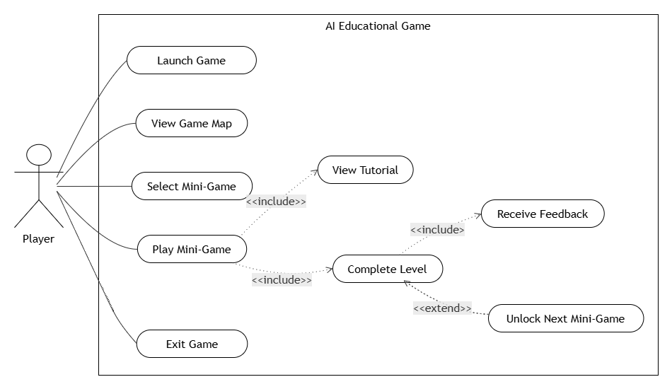
Figure 1.3: General Use Case Diagram
A use case diagram showing the player as the sole actor, able to launch the game, view the map, select and play a mini-game, view its tutorial, and receive feedback before unlocking the next activity.

The educational application involves a single primary actor: the Player, representing the child using the application. Through the world map, the player can access the available educational mini-games, complete learning activities, receive feedback, and progress through the different stages of the Artificial Intelligence learning journey.
The general use case diagram shown in Figure 1.3 illustrates the interactions between the player and the main functionalities offered by the system.

Conclusion
This chapter introduced the general context of the project by presenting the host company, the problem addressed, the proposed solution, and the project objectives. It also defined the functional and non-functional requirements that guided the development of the educational application. These elements establish the foundation for the design and implementation choices presented in the following chapters.

Chapter 2

System Architecture

Development Technologies

Project Management Methodology

Introduction
This chapter presents the technical organization adopted during the development of the educational game. It first describes the overall system architecture, followed by the development technologies and software tools used throughout the project. The chapter also introduces the Agile Scrum methodology adopted to manage the development process, the product backlog that defines the project requirements, the sprint planning established during the internship, and the research work conducted on integrating an Artificial Intelligence voice recognition model into the application.

2.1 Game Architecture
The educational application was designed using a modular architecture in which each mini-game represents a specific stage of the Artificial Intelligence learning process. The application is organized around a central Game Map that manages navigation and player progression while providing access to the different educational modules. This architecture promotes modularity, scalability, and maintainability, allowing new educational activities to be integrated with minimal modifications to the existing system.

2.1.1 Overall System Architecture
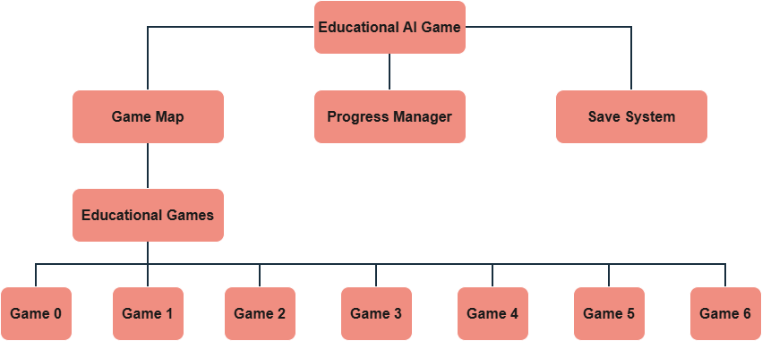
Figure 2.1: Overall System Architecture
A component diagram showing the application split into a Game Map, a Progress Manager, and a Save System, with the Game Map giving access to the seven educational mini-games.

Figure 2.1 illustrates the overall architecture of the educational application. The Game Map acts as the central navigation module, allowing players to access the different mini-games while managing progression and unlocked content. Each mini-game operates independently and focuses on a specific Artificial Intelligence concept, making the application modular and easy to extend.

2.1.2 AI Learning Architecture
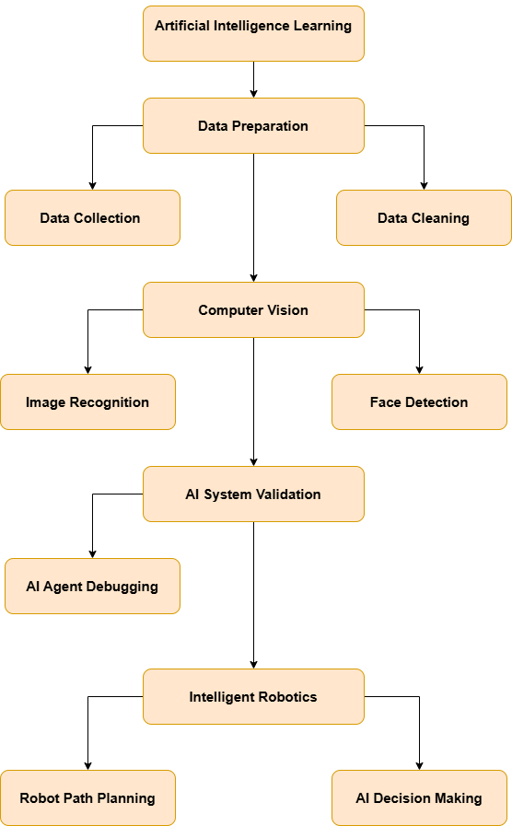
Figure 2.2: AI Learning Architecture
A tree diagram tracing the AI learning pipeline from data preparation through computer vision, AI system validation, and intelligent robotics.
Figure 2.2 presents the educational Artificial Intelligence learning pipeline implemented by the application. Instead of teaching programming concepts directly, the platform introduces children to the main stages involved in developing intelligent systems. Learners begin by understanding how data is collected and prepared before discovering computer vision concepts such as image recognition and face detection. They then explore AI system debugging and finally learn how intelligent robots plan paths and make decisions to accomplish specific tasks.
Table 2.1: AI Learning Mapping Across Domains, Concepts, and Mini-Games
AI Domain | Concept Taught | Implemented Mini-Game
Data Preparation | Data Collection | Data Gathering
Data Preparation | Data Cleaning | Data Cleaning
Computer Vision | Image Recognition | Image Recognition Evaluation
Computer Vision | Face Detection | Face Detection
AI Validation | AI System Debugging | AI Agent Debugging
Intelligent Robotics | Robot Path Planning | Robot Path Planning
Intelligent Robotics | AI Decision Making | AI Decision Making
Cross-references each AI domain with the specific concept and mini-game that teaches it.

2.2 Technologies Used
The development of the educational game required the use of several software technologies and development tools. Each technology was selected according to its role in the design, implementation, version control, project management, and communication throughout the internship.

2.2.1 Unity

Figure 2.3: Unity Logo
The official Unity logo, representing the game engine used to build the application.
Unity is the main game engine used to develop the application. It provides a complete environment for creating 2D games, managing scenes, animations, user interfaces, physics, audio, and game objects. Unity was also used to implement the seven educational mini-games, the world map, player progression, and scene management.

2.2.2 C#

Figure 2.4: C# Logo
The official C# logo, representing the programming language used throughout the project.
C# is the programming language used throughout the project. It was used to implement the gameplay mechanics, drag-and-drop interactions, level progression, scoring system, tutorials, robot behaviors, and communication between the different game components. Its object-oriented approach allowed the application to be organized into reusable and maintainable scripts.

2.2.3 Visual Studio

Figure 2.5: Visual Studio Logo
The official Visual Studio logo, representing the IDE used to write and debug the code.
Visual Studio served as the Integrated Development Environment (IDE) for the project. It provided advanced code editing, debugging, error detection, and testing tools, facilitating the implementation and maintenance of the application's source code.

2.2.4 Krita



Figure 2.6: Krita Logo

The official Krita logo, representing the digital painting tool used to create the game's graphical assets.
Krita was used to design and edit various graphical assets integrated into the game. It was mainly employed for creating backgrounds, educational illustrations, characters, decorative elements, and visual resources adapted to young learners.

2.2.5 Git

Figure 2.7: Git Logo
The official Git logo, representing the version control system used to track the source code.
Git is a distributed version control system used to track changes made to the project's source code. It enabled efficient version management while preserving the complete development history of the application.

2.2.6 GitHub

Figure 2.8: GitHub Logo
The official GitHub logo, representing the platform used to host the project's repository.
GitHub was used as the remote repository hosting platform. It allowed project versions to be synchronized, source code to be securely stored, and collaboration with supervisors and team members to be simplified throughout the development process.

2.2.7 ClickUp
Figure 2.9: ClickUp Logo
The official ClickUp logo, representing the tool used to plan and track development tasks.
ClickUp is a project management platform used to organize development tasks, monitor project progress, assign activities, and follow the completion of planned objectives during the internship.

2.2.8 Slack

Figure 2.10: Slack Logo
The official Slack logo, representing the platform used for team communication during the internship.
Slack was used as the primary communication platform between team members and supervisors. It facilitated discussions, project updates, technical support, and the sharing of documents and development progress during the internship.

2.3 Project Management Methodology
The development of the educational game followed the Agile Scrum methodology. Scrum was selected because it supports iterative and incremental development, allowing the project to evolve through continuous implementation, testing, and feedback. This approach facilitated the integration of new functionalities while ensuring that each completed feature met the project's educational objectives.

2.3.1 Scrum Methodology
Scrum is an Agile project management framework that divides a project into short development cycles called Sprints. At the end of each Sprint, a functional increment of the product is delivered, tested, and reviewed before starting the next iteration. This iterative process improves flexibility, promotes collaboration, and enables rapid adaptation to changing requirements.

2.3.2 Scrum Roles
The Scrum framework defines three main roles that contribute to the successful development of the project.

Product Owner
The Product Owner defines the project requirements, prioritizes the Product Backlog, and ensures that the developed features satisfy the educational objectives of the application.

Scrum Master
The Scrum Master facilitates the development process by ensuring that Scrum practices are correctly applied, removing obstacles encountered during development, and promoting effective collaboration within the team.

Development Team
The Development Team is responsible for designing, implementing, testing, and integrating the different components of the educational game. Throughout the internship, development activities included gameplay programming, user interface implementation, debugging, asset integration, and feature optimization.

Table 2.2: Scrum Roles and Responsibilities

Scrum Role | Team Member | Responsibilities
Product Owner | Mouadh Mkadmi | Defines the project vision, prioritizes the product backlog, validates completed features, and ensures that the developed application meets the educational objectives and project requirements.
Scrum Master | Yassine Alaoui | Supervises the development process, provides technical guidance, removes development obstacles, and ensures that Scrum practices are properly followed throughout the project.
Development Team | Ranym Moussa | Designs, develops, tests, and integrates the educational mini-games, implements the user interface and gameplay mechanics, and manages project updates using the Scrum workflow.
Lists the three Scrum roles held during the project, who filled each one, and their responsibilities.
The project was developed following the Scrum framework. Each team member assumed a specific role to ensure efficient project management, clear communication, and continuous delivery of functional increments. Table 2.2 summarizes the Scrum roles adopted throughout the development process.

2.3.3 Scrum Artifacts
Scrum defines three main artifacts that organize and monitor project development.

Product Backlog
The Product Backlog contains all functional and technical requirements identified for the educational application. Each backlog item represents a feature or improvement that contributes to the final product.

Sprint Backlog
The Sprint Backlog contains the set of tasks selected from the Product Backlog for implementation during the current Sprint. These tasks are planned according to their priority and estimated development effort.

Product Increment
The Product Increment represents the functional result obtained at the end of each Sprint. Each increment is tested and validated before being integrated into the complete educational application.

2.3.4 Scrum Events
The Scrum methodology is organized around several recurring events that structure the development process.

Sprint Planning
Sprint Planning defines the objectives and tasks to be completed during the upcoming Sprint. Development priorities are established according to the Product Backlog.

Daily Scrum
Daily Scrum meetings allow the development team to monitor project progress, discuss completed tasks, identify encountered issues, and plan the activities for the following day.

Sprint Review
At the end of each Sprint, the implemented functionalities are demonstrated and evaluated. Feedback collected during this phase is used to improve future iterations.

Sprint Retrospective
The Sprint Retrospective is conducted after each Sprint to analyze the development process, identify strengths and weaknesses, and define improvements for the next iteration.

2.3.5 Application of Scrum to the Project
The Scrum methodology was applied throughout the development of the educational game. Development activities were organized using ClickUp, where tasks were planned, assigned, and monitored according to their priorities. Team communication and progress discussions were carried out through Slack, enabling efficient collaboration with the internship supervisor and development team.
Each completed feature was integrated, tested, and validated before continuing with the implementation of new functionalities. This iterative workflow improved software quality, simplified debugging, and ensured continuous progress throughout the internship.

2.4 Product Backlog
The Product Backlog defines the functional requirements of the educational AI game in the form of user stories. Each user story describes a feature from the learner's perspective and represents a value that the application must deliver. The backlog was continuously refined throughout the development process according to the project's priorities and educational objectives.
Table 2.3: Product Backlog
Sprint | User Story ID | User Story | Priority
Sprint 1 | US1 | As a learner, I want to sort different animals into their correct categories so that I can understand the concept of data gathering. | High
 | US2 | As a learner, I want to receive immediate feedback after each classification so that I can identify my mistakes. | High
 | US3 | As a learner, I want to complete the activity and automatically return to the Game Map. | Medium
Sprint 2 | US4 | As a learner, I want to classify different objects into their appropriate categories to understand data cleaning. | High
 | US5 | As a learner, I want to progress through several levels and sub-levels with increasing difficulty. | High
 | US6 | As a learner, I want my progress to be saved after completing each level. | Medium
Sprint 3 | US7 | As a learner, I want to evaluate the robot's image recognition predictions. | High
 | US8 | As a learner, I want to receive immediate feedback after every evaluation. | High
 | US9 | As a learner, I want to unlock the next educational activity after completing the game. | Medium
Sprint 4 | US10 | As a learner, I want to determine whether the robot correctly detects faces in images. | High
 | US11 | As a learner, I want to complete all evaluation rounds before returning to the Game Map. | Medium
Sprint 5 | US12 | As a learner, I want to identify faulty AI agents and remove them while preserving the correct ones. | High
 | US13 | As a learner, I want to receive immediate visual feedback for each action. | Medium
Sprint 6 | US14 | As a learner, I want to arrange movement commands to guide the robot safely through a maze. | High
 | US15 | As a learner, I want the robot to execute my commands and display the result. | High
Sprint 7 | US16 | As a learner, I want to arrange action cards that help the robot overcome obstacles and reach its destination. | High
 | US17 | As a learner, I want to understand how AI selects the appropriate action for different situations. | High
Sprint 8 | US18 | As a learner, I want to access all unlocked educational activities through the Game Map. | High
 | US19 | As a learner, I want my progression to be automatically saved and displayed on the map. | High
Lists every user story in the product backlog, grouped by sprint, with its priority.

2.5 Sprint Planning
Sprint Planning was conducted before the beginning of each development iteration to define the sprint objective, select the corresponding user stories from the Product Backlog, and estimate the implementation duration. The project was completed over a period of four months (16 weeks), during which each sprint delivered a functional increment of the educational application.

Table 2.4: Sprint Planning
Sprint | Sprint Goal | Selected User Stories | Duration
Sprint 1 | Develop the Data Gathering educational activity. | US1 – US3 | Weeks 1–2
Sprint 2 | Develop the Data Cleaning educational activity. | US4 – US6 | Weeks 3–4
Sprint 3 | Develop the Image Recognition Evaluation educational activity. | US7 – US9 | Weeks 5–6
Sprint 4 | Develop the Face Detection educational activity. | US10 – US11 | Weeks 7–8
Sprint 5 | Develop the AI Agent Debugging educational activity. | US12 – US13 | Weeks 9–10
Sprint 6 | Develop the Robot Path Planning educational activity. | US14 – US15 | Weeks 11–12
Sprint 7 | Develop the AI Decision Making educational activity. | US16 – US17 | Weeks 13–14
Sprint 8 | Develop the Game Map and integrate the complete application. | US18 – US19 | Weeks 15–16
Lists each sprint's goal, the user stories it covers, and its two-week duration across the sixteen-week project.

2.6 Artificial Intelligence Module
2.6.1 Introduction
To further enrich the educational experience, an Artificial Intelligence module has been incorporated into the application. Unlike the previous activities, which introduce AI concepts through interactive simulations, this module integrates a real speech recognition system that enables learners to control a virtual robot using voice commands.
The primary objective of this module is to provide children with a practical understanding of how intelligent systems perceive and interpret spoken language. By interacting directly with the AI model, learners gain hands-on exposure to one of the most widely adopted applications of Artificial Intelligence in modern technology.
At the current stage of development, the system recognizes six spoken categories: four navigation commands (up, down, left, right) together with two rejection categories, unknown and silence, which allow the model to withhold a prediction when no clear command is spoken. The integration of Arabic and French speech recognition is planned as part of the future evolution of the application, with the objective of offering a multilingual educational experience.

2.6.2 Artificial Intelligence Domain
Artificial Intelligence (AI) is a multidisciplinary field of computer science dedicated to the design of systems capable of performing tasks that traditionally require human cognitive abilities, including learning, reasoning, perception, and decision-making.
The proposed solution belongs to the domain of Automatic Speech Recognition (ASR), commonly referred to as Speech Recognition. This technology enables computer systems to convert spoken language into machine-interpretable commands, allowing natural interaction between users and intelligent applications.
From a machine learning perspective, the developed solution is based on Supervised Learning, where the model is trained using labeled audio recordings. During the learning process, the network establishes the relationship between speech patterns and their corresponding navigation commands, enabling accurate prediction when processing previously unseen voice inputs.
The technological hierarchy of the adopted solution is presented in Figure 2.11.
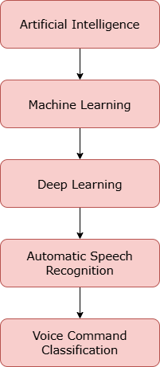
Figure 2.11. Artificial Intelligence hierarchy adopted in the proposed solution.
A flowchart placing the voice recognition feature within the broader AI field, narrowing from Artificial Intelligence down to Voice Command Classification.

2.6.3 Deep Learning Model
The speech recognition system was developed using a Convolutional Neural Network (CNN) implemented with the PyTorch deep learning framework.
The proposed architecture, referred to as VoiceCNN, is designed to automatically extract meaningful acoustic features from speech signals and classify them into one of the six predefined categories. The network takes as input a single-channel log-mel spectrogram of shape 98×40 (98 time frames by 40 mel-frequency bands) and outputs a score for each of the six classes. It consists of multiple convolutional layers responsible for feature extraction, followed by fully connected layers that perform the final classification task. ReLU activation functions are employed to improve the network's learning capability, while Dropout regularization minimizes overfitting and enhances generalization performance.
The overall processing architecture is illustrated in Figure 2.12.
Figure 2.12. VoiceCNN processing architecture.

2.6.4 Model Selection
Several deep learning architectures have been successfully applied to speech recognition problems, including Recurrent Neural Networks (RNNs), Long Short-Term Memory (LSTM) networks, Transformer-based architectures, and Convolutional Neural Networks (CNNs).
For the proposed educational application, the CNN architecture was selected due to its favorable balance between recognition accuracy, computational efficiency, and execution speed. Unlike sequential models, CNNs effectively capture local spectral characteristics of speech while requiring significantly lower computational resources, making them particularly suitable for real-time educational applications developed with Unity.
Furthermore, the lightweight nature of the architecture facilitates deployment on standard computing devices without requiring specialized hardware.

Table 2.5. Justification for Selecting CNN

Evaluation Criterion | CNN
Speech classification performance | Excellent
Computational efficiency | High
Real-time inference capability | Excellent
Integration with Unity | Excellent
Suitability for compact datasets | High
Compares the CNN architecture against the evaluation criteria used to justify its selection for the speech recognition module.

2.6.5 Dataset Preparation
The training dataset was constructed using the Google Speech Commands v0.02 dataset, a publicly available collection containing thousands of labeled recordings of isolated English words produced by numerous speakers.
Within the current implementation, the classifier distinguishes six categories: the four navigation commands (up, down, left, right) required by the educational activity, together with an unknown class covering out-of-vocabulary words and a silence class covering background noise or the absence of speech. Combined with a confidence threshold applied at inference time, this rejection mechanism prevents the robot from reacting to unclear or accidental audio input.
Future versions of the application will extend the dataset by incorporating Arabic and French voice recordings, thereby enabling multilingual interaction and improving the accessibility of the educational platform.

Table 2.6. Voice Command Categories

Command | Function
Up | Moves the robot upward
Down | Moves the robot downward
Left | Moves the robot left
Right | Moves the robot right
Unknown | Represents unsupported spoken words
Silence | Represents the absence of speech
Lists the six voice command categories recognized by the model and the movement each one triggers.

2.6.6 Audio Preprocessing
Prior to training, each audio recording undergoes a sequence of preprocessing operations intended to standardize the input data and enhance the learning performance of the neural network.
Each one-second recording, sampled at 16 kHz (16,000 raw audio samples), is first normalized to reduce amplitude variations. The signal is then divided into overlapping analysis frames of 400 samples (25 ms) with a hop size of 160 samples (10 ms), producing 98 frames per clip. Each frame is windowed with a Hann function and converted to the frequency domain using a 512-point Fast Fourier Transform. The resulting power spectrum is projected onto 40 triangular mel filters spanning 20 Hz to 8 kHz, and the filter outputs are log-compressed to obtain the final log-mel spectrogram, a 98×40 matrix that serves as the input to VoiceCNN.
This exact pipeline, including the sample rate, frame length, hop size, FFT size, number of mel bands, and frequency range, is re-implemented independently in C# (MelSpectrogram.cs) so that Unity Sentis reproduces the same features at inference time as those used during training in PyTorch. Since Sentis performs fully offline inference with no access to Python audio libraries, this parity between the training and runtime pipelines is essential for the model's predictions to remain valid once deployed in the game.
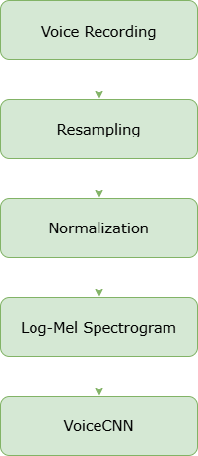
Figure 2.13. Audio preprocessing pipeline.
A flowchart of the steps applied to each recording before classification: voice recording, resampling, normalization, conversion to a log-mel spectrogram, and input into VoiceCNN.

2.6.7 Model Training
The neural network was trained using the PyTorch deep learning framework. During training, the dataset was divided into training and validation subsets to evaluate the generalization capability of the model throughout the learning process.
The optimization procedure relies on the Adam optimizer, while the Cross-Entropy Loss function is employed to quantify the classification error between predicted and expected outputs. Throughout successive training epochs, the network parameters are iteratively updated until satisfactory recognition performance is achieved.
The model exhibiting the highest validation accuracy is retained for deployment within the educational application.
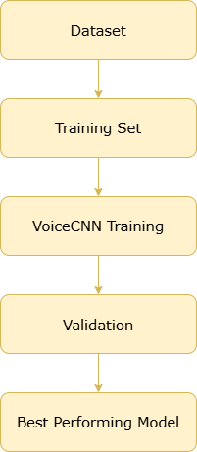
Figure 2.14. Model training workflow.
A flowchart of the training process: preparing the dataset, splitting it into a training set, training VoiceCNN, validating its performance, and retaining the best performing model.

2.6.8 Integration with the Educational Application
Following the training phase, the neural network is exported in the ONNX format to ensure interoperability with the Unity game engine. The exported model is loaded through Unity Sentis using ModelLoader.Load and executed on the CPU backend, enabling fully offline inference directly within the educational application without any dependency on network connectivity or specialized graphics hardware.
During gameplay, the learner presses and holds a microphone button to record up to three seconds of audio; the recording stops as soon as the button is released. The captured waveform is centered or padded to the exact one-second window expected by the model and converted into a log-mel spectrogram using the same preprocessing routine described above. Sentis returns raw class scores, which are converted into probabilities with a softmax function computed manually in C#. If the highest probability falls below a confidence threshold of 60%, or corresponds to the silence or unknown class, the prediction is discarded and no action is taken. Otherwise, the recognized command is mapped to the corresponding movement block, which is automatically added to the robot's program panel exactly as if the learner had dragged it manually, allowing voice and drag-and-drop input to be used interchangeably during the Robot Path Planning activity.

Figure 2.15. Integration of the speech recognition model within the Unity application.

2.6.9 Current Status and Future Enhancements
At the time of writing this report, the speech recognition module is undergoing continuous refinement and evaluation. The current implementation successfully recognizes English navigation commands, demonstrating the feasibility of integrating real-time speech recognition into an educational game environment.
Future development will focus on extending the model to support Arabic and French, expanding the training dataset with recordings from diverse speakers, improving robustness in noisy environments, and optimizing the model to achieve higher recognition accuracy and faster inference performance. These enhancements aim to provide a more inclusive and effective multilingual learning experience while further demonstrating the practical applications of Artificial Intelligence in educational software.

2.7 Child-Centered Design and Software Engineering Practices
Beyond the AI-specific concepts covered in each mini-game, several design and engineering practices are applied consistently across the entire application. These were treated as shared, reusable patterns rather than one-off implementation details, reflecting standard software engineering principles of separation of concerns and code reuse applied to a children's educational context.
2.7.1 Guided Tutorials
Every mini-game is preceded by a dedicated, scripted tutorial rather than a static instructions screen. Each tutorial is implemented as its own component, built as a coroutine-driven sequence of steps rather than a monolithic block of setup code, with a version tailored to each activity: EvaluationTutorialManager for the Image Recognition Evaluation activity, KidTutorialManager for Data Cleaning, and TutorialManager for Data Gathering, among others. At each step, an animated mascot character named Ferid appears next to a right-to-left Arabic speech bubble, paired with a matching pre-recorded voice line, while a hand icon with a gentle bobbing and squashing animation points directly at whatever the learner is expected to interact with next. A dark overlay, combined with dynamically bringing only the relevant elements above it at each step, reveals the screen piece by piece instead of showing the whole gameplay view at once, which keeps the experience manageable for a five to ten year old audience.
Rather than scripting a fake demonstration, each tutorial drives the real gameplay manager through public callback methods. For instance, the Data Cleaning tutorial deliberately drags a correct animal into the wrong container first, holds a red flash on the target zone while narrating why the placement is wrong, and only then walks through the correct placement with a green flash, before handing control back to the activity manager for free play. This mistake-then-correction sequence is a deliberate pedagogical choice: it lets a child see and understand a wrong answer's consequence in a safe, guided context before ever being scored on one. Because each tutorial calls directly into the same manager classes used during real gameplay instead of keeping a separate simplified copy of the game logic, the guided walkthrough and the real activity can never drift out of sync with one another.
2.7.2 Shared Software Engineering Patterns
Several patterns recur across every mini-game's implementation. A shared component gives every activity manager the same simple way to report that a level is finished, which keeps each mini-game's internal logic separate from how the Game Map interprets and saves progress. Persistent state, including unlocked levels, per-level completion status, and the drone's last position on the map, is centralized in a single progress-tracking singleton built on top of Unity's PlayerPrefs, rather than each activity managing its own save data. Audio feedback for actions such as drops, correct or incorrect verdicts, and level completion is routed through one central audio manager, which keeps sound design consistent across activities that were otherwise built independently of one another.
Arabic text throughout the application, including tutorial dialogue and in-game feedback messages, is rendered through a shared right-to-left text component from the UPersian localization library rather than Unity's default text components, which ensures correct layout everywhere text appears. Finally, round and level progression in every activity is implemented as a Unity coroutine acting as a small state machine, which keeps the sequencing logic, waiting for an animation, then a player action, then the next state, readable as a straightforward series of steps instead of being spread across multiple callback handlers.

Conclusion
This chapter presented the overall architecture of the educational application, the technologies adopted throughout the development process, and the Agile Scrum methodology used for project management. It also introduced the Artificial Intelligence module integrated into the application and described its design principles and development approach. The next chapters focus on the implementation of each educational activity through the different development iterations.

Chapter 3

Sprint 1 - 3

Introduction
This chapter presents the analysis, design, and implementation of the educational application. The development process was divided into several sprints, each corresponding to one educational mini-game. For every sprint, the functional requirements, system design, UML diagrams, and implementation are presented to illustrate the development process followed throughout the project.

3.1 Sprint 1: Data Gathering

3.1.1 Sprint Overview
The objective of this sprint is to develop the first educational activity, introducing children to the concept of Data Gathering, which represents the initial stage of the Artificial Intelligence workflow. The activity demonstrates that AI systems require sufficient and well-organized data before they can perform learning or make accurate predictions.
The gameplay consists of dragging different animal elements into their corresponding categories. Through this interactive activity, learners understand the importance of collecting and organizing data correctly before it can be used to build intelligent systems.

3.1.2 Sprint Backlog
Table 3.1: Sprint 1 Backlog
No. | Development Tasks | Priority
1 | Design the graphical user interface (GUI) | High
2 | Create and integrate animal assets | High
3 | Implement the drag-and-drop interaction mechanism | High
4 | Develop category drop zones | High
5 | Implement answer validation logic | High
6 | Display visual feedback for player actions | Medium
7 | Manage game completion and progression | High
8 | Return the learner to the Game Map | High
Lists the development tasks completed during Sprint 1 and their priority.

3.1.3 Activity Workflow
The Data Gathering activity introduces the learner to the concept of collecting and organizing training data for Artificial Intelligence. At the beginning of the activity, the system initializes the game scene and displays an interactive tutorial explaining the learning objective and the drag-and-drop mechanics. Once the tutorial is completed, the learner can classify the displayed animals into their corresponding categories. Every successful placement immediately updates the target container, while incorrect attempts are ignored until the correct category is selected. The application continuously verifies the number of correctly classified objects. When all required categories are completed, a success message is displayed and the player's progression is saved before returning to the Game Map.
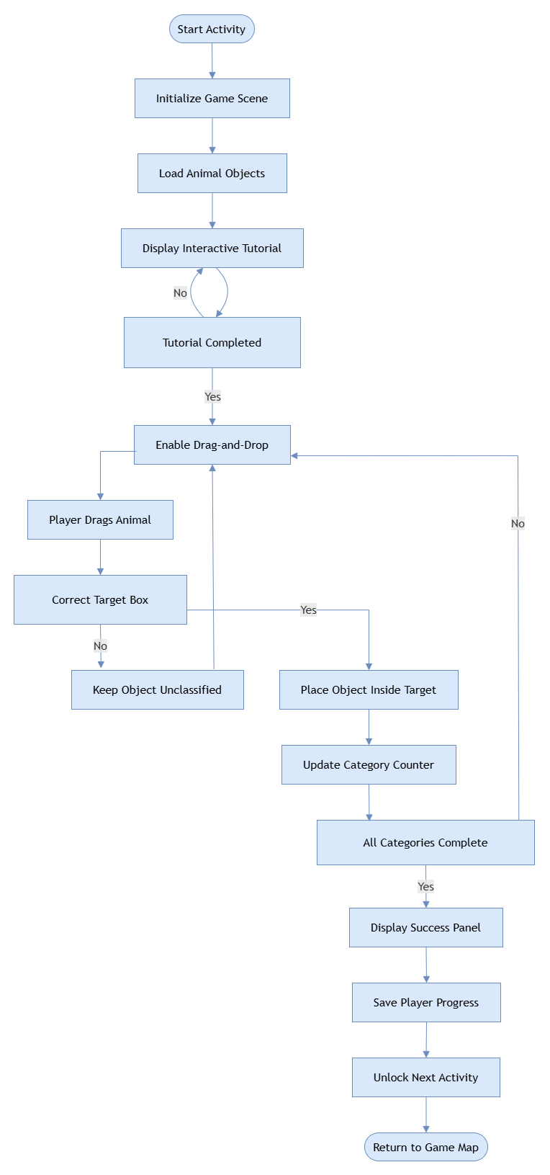
Figure 3.1. Activity Workflow Data Gathering
A flowchart of the Data Gathering activity, from initializing the scene and tutorial through the classification loop to saving progress and returning to the Game Map.

3.1.4 Realization
The Data Gathering activity was implemented using Unity and C#. A drag-and-drop interaction system enables learners to classify animal objects into their appropriate categories. Before the scored activity begins, a dedicated tutorial walks the learner through a mascot-guided introduction, including a staged wrong-then-correct placement demonstration, using the same drag-and-drop components as the real game. Each interaction is validated in real time, and immediate visual feedback is provided to reinforce the learning objective. Once all objects have been correctly classified, the activity is completed, the player's progression is saved, and the application automatically returns to the Game Map.
The following figures illustrate the main interfaces of the Data Gathering activity.
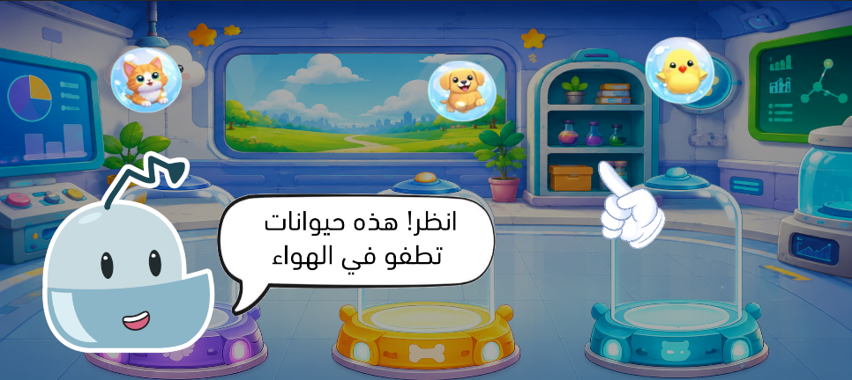
Figure 3.2: Data Gathering gameplay tutorial.
Ferid the mascot introduces the activity, pointing out the animals floating above their glass display pedestals before gameplay begins.

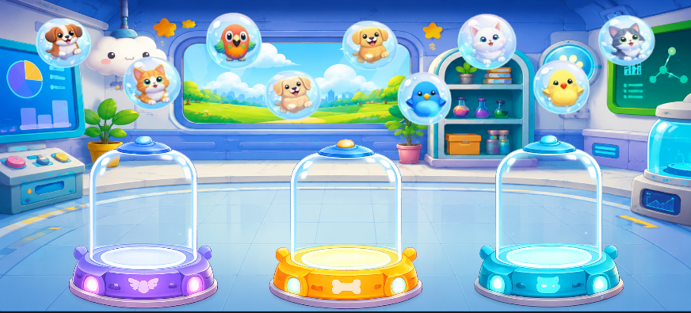
Figure 3.3: Data Gathering gameplay interface
The main play screen, showing several animal bubbles floating above three empty category pedestals waiting to be sorted.

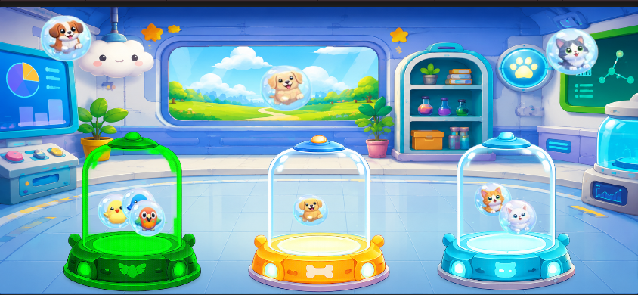
Figure 3.4: Correct object classification
Several animals placed inside their matching pedestals, with one animal bubble still left to be sorted.

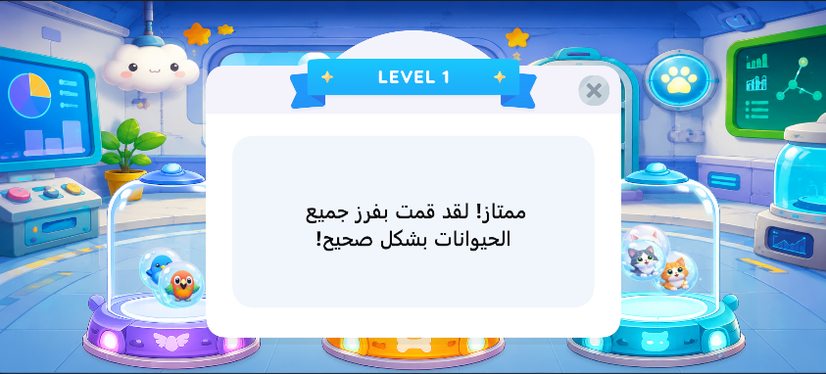
Figure 3.5: Success Panel
The level-completion popup congratulating the learner for correctly sorting every animal.

3.2 Sprint 2: Data Cleaning

3.2.1 Sprint Overview
The second sprint focuses on the implementation of the Data Cleaning activity. Its objective is to demonstrate that collected data must be organized and cleaned before being used to train Artificial Intelligence models. This educational activity encourages learners to identify and correctly classify different objects into their appropriate categories.
Unlike the previous activity, this sprint introduces multiple levels and sub-levels with progressively increasing difficulty, allowing learners to strengthen their observation and classification skills.

3.2.2 Sprint Backlog
Table 3.2: Sprint 2 Backlog
No. | Development Tasks | Priority
1 | Design the graphical user interface (GUI) | High
2 | Create educational assets | High
3 | Implement drag-and-drop mechanics | High
4 | Develop category validation zones | High
5 | Implement multi-level and sub-level management | High
6 | Validate learner interactions | High
7 | Display visual feedback and scoring | Medium
8 | Update player progression | High
Lists the development tasks completed during Sprint 2 and their priority.

3.2.3 Activity Workflow
The Data Cleaning activity simulates the preprocessing stage commonly performed before training Artificial Intelligence models. After loading the selected level, the application initializes the current sub-level, activates the required number of objects, and randomly distributes them between the two classification zones. To encourage active learning, the system intentionally places a portion of the objects in incorrect categories, preventing the learner from succeeding without interaction. After reviewing the data, the learner validates the arrangement. If every object has been correctly sorted, the system advances to the next sub-level or completes the level. Otherwise, the current round is regenerated with a new randomized distribution, allowing the learner to attempt the activity again.

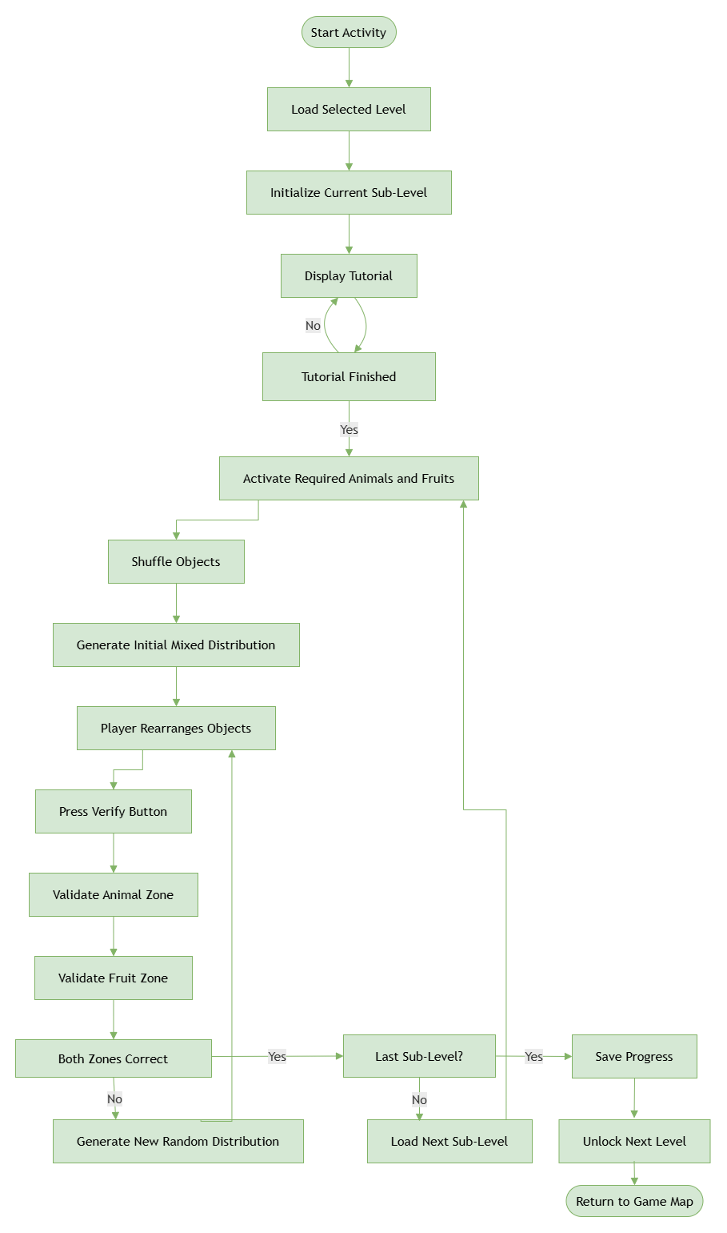
Figure 3.6. Activity Workflow Data cleaning
A flowchart of the Data Cleaning activity, showing the sub-level loop in which objects are deliberately mis-sorted, then reviewed and corrected before the learner submits an answer.

3.2.4 Realization
The activity's difficulty curve is implemented through a two-dimensional structure of levels and sub-levels, where each sub-level is treated as an independent round with its own object count and its own deliberately imperfect starting arrangement. Rather than validating each drag individually, the system checks the whole arrangement only when the learner submits it, which better matches the real data-cleaning workflow of reviewing a full batch before confirming it is clean. A companion guided tutorial runs the learner through the activity beforehand, including an explicit wrong-placement demonstration with narrated red and green flash feedback, before releasing control to the learner for free play. Learners classify different objects into the correct categories while the application validates each interaction and provides immediate feedback. The progression system automatically advances through sub-levels until the current level is completed, after which the learner returns to the Game Map.
The following figures illustrate the main interfaces of the Data Cleaning activity.
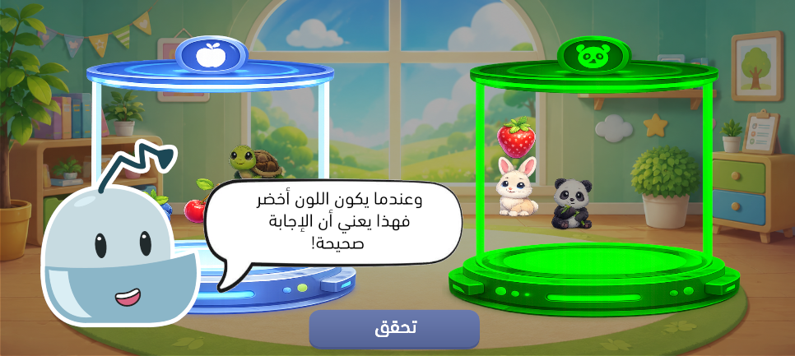
Figure 3.7: Data Cleaning gameplay tutorial.
Ferid the mascot walks the learner through the animal and fruit sorting zones before real play begins.
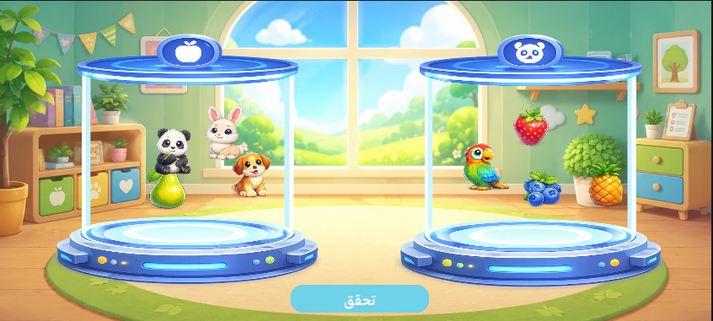
Figure 3.8: Data Cleaning gameplay interface.
The main play screen, showing animals and fruits distributed between the two category zones, some deliberately placed in the wrong one.

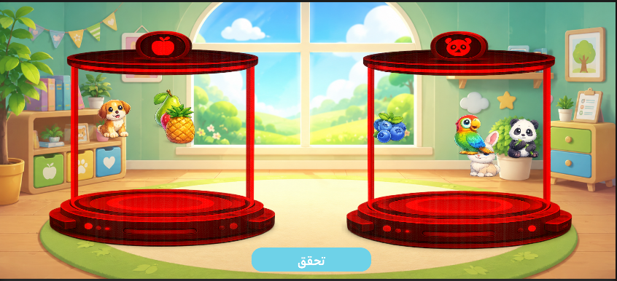
Figure 3.9: Wrong classification
An item left in the incorrect zone, highlighted in red to show the learner it needs to be moved.

3.3 Sprint 3: Image Recognition Evaluation

3.3.1 Sprint Overview
The third sprint introduces the concept of Image Recognition, one of the fundamental applications of Computer Vision. Rather than training an AI model, learners evaluate whether the robot correctly identifies the objects displayed on the screen. This activity highlights the importance of verifying AI predictions to ensure reliable system performance.
The gameplay is organized into multiple rounds, each presenting a new recognition scenario that learners must evaluate before receiving immediate feedback.

3.3.2 Sprint Backlog
Table 3.3: Sprint 3 Backlog
No. | Development Tasks | Priority
1 | Design the graphical user interface (GUI) | High
2 | Create image recognition scenarios | High
3 | Display AI predictions | High
4 | Implement the prediction evaluation mechanism | High
5 | Validate learner responses | High
6 | Manage gameplay rounds | High
7 | Display visual feedback | Medium
8 | Update player progression | High
Lists the development tasks completed during Sprint 3 and their priority.

3.3.3 Activity Workflow
The Image Recognition Evaluation activity allows the learner to assess the predictions generated by an Artificial Intelligence model. After completing the tutorial, the system generates a new evaluation round by assigning labels to the displayed images. Some labels correspond to the correct prediction, while others are intentionally replaced with incorrect values selected from a predefined vocabulary. The robot automatically labels each image before entering the evaluation phase. The learner then analyzes every prediction individually and determines whether the robot's decision is correct or incorrect. After all predictions have been evaluated, the system computes the robot's accuracy, updates the performance indicator, and either starts a new evaluation round or displays the final results when all rounds have been completed.
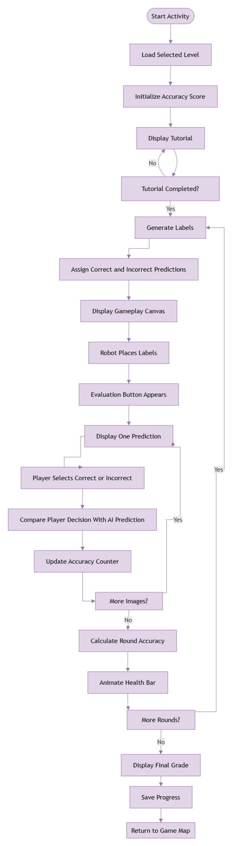
Figure 3.10. Activity Workflow Image Recognition Evaluation
A flowchart of the Image Recognition Evaluation activity, from the robot labelling the displayed images to the learner judging each prediction and the system updating the robot's accuracy.

3.3.4 Realization
The activity is built around a shared data store that tracks the robot's simulated accuracy, an internal score rather than a real trained model, initialized at 30% and bounded between 10% and 100%, together with the current level and round. It spans three thematic levels (emotions, directions, and animals), each played over four rounds. At the start of a round, the number of images the robot labels correctly is derived directly from the current accuracy value, so a robot with a higher score is visibly more reliable before the learner even starts judging it; the robot then hops between the images and reveals each label in turn. The learner reviews the same labelled images, reused rather than duplicated so the two views stay in sync, and judges each as correct or incorrect. A dedicated guided tutorial walks the learner through one live round before scored play begins, using the same underlying activity manager rather than simulating it separately. If at least half of a round's judgements agree with the ground truth, accuracy increases by a fixed step; otherwise it decreases by the same step, giving a visible, gradually improving health bar. After completing all rounds of a level, a results panel reports the final accuracy and a qualitative grade before the learner returns to the Game Map.
The following figures illustrate the main interfaces of the Image Recognition Evaluation activity.
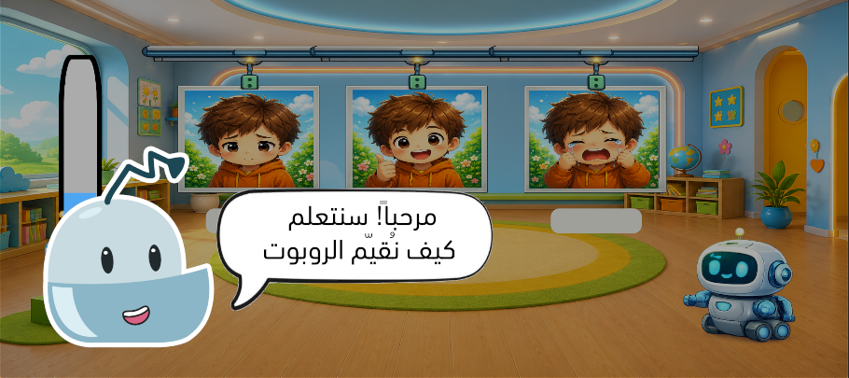
Figure 3.11: Image Recognition gameplay tutorial.
The robot hops between the photos on the board, placing a label under each one while the learner watches.

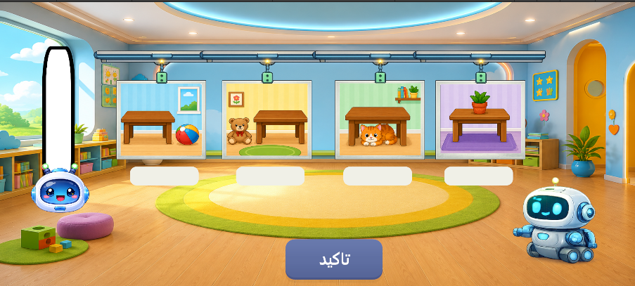
Figure 3.12: Image Recognition gameplay interface.
The main play screen, showing the robot's labelled photo board alongside the evaluate button.

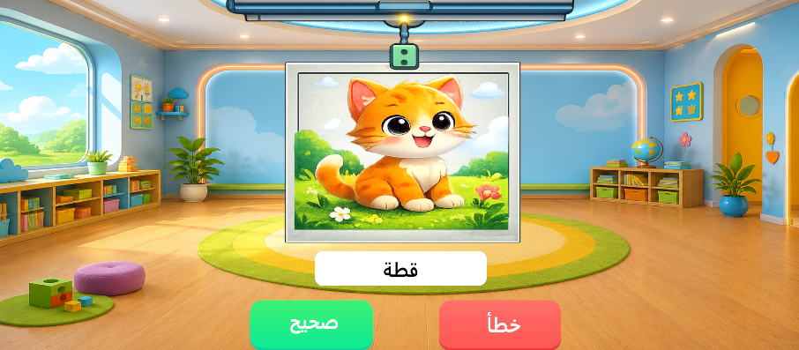
Figure 3.13: Evaluation screen.
The second screen, where the learner reviews a single labelled photo and judges it as correct or incorrect.

3.4 UML Modeling
To provide a structural representation of the first three sprints, the following UML diagrams illustrate the common interactions between the player and the educational application, the execution flow of a gameplay session, and the principal software classes involved in the implementation.

3.4.1 Use Case Diagram
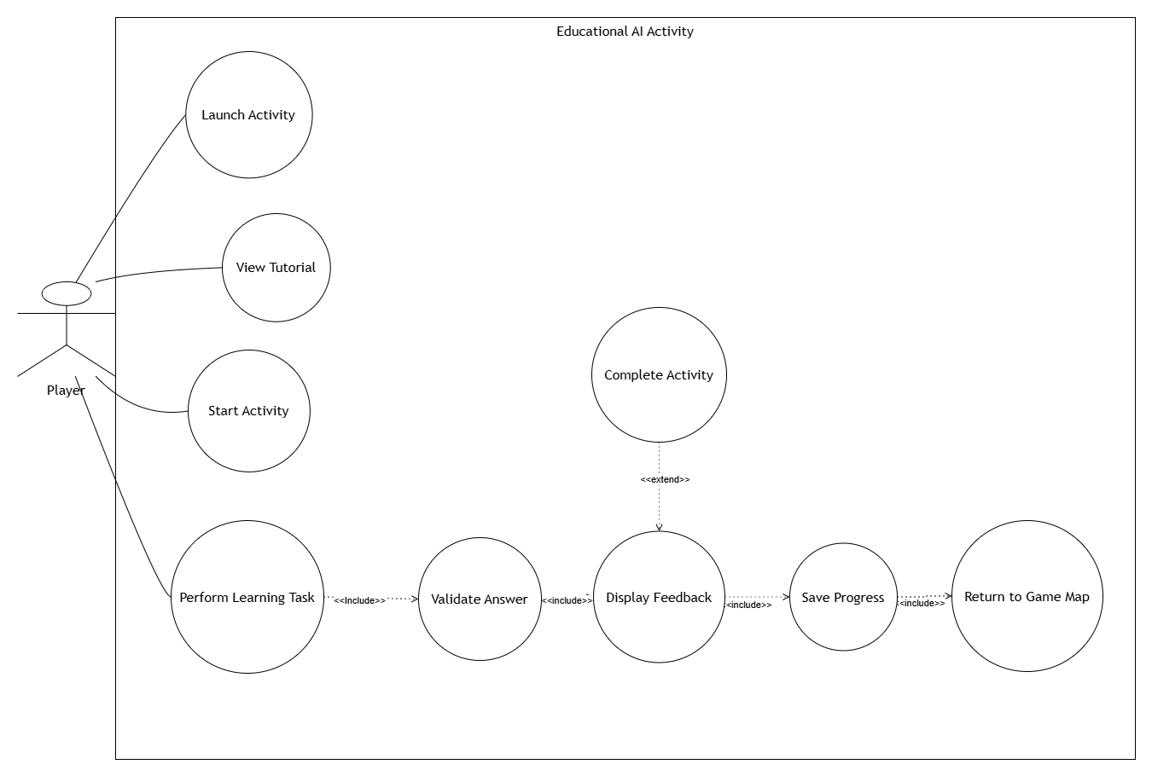
Figure 3.14: Use Case Diagram of the Data Preparation and Image Recognition modules.
A use case diagram showing the player launching an activity, viewing its tutorial, performing the learning task, and receiving feedback before progress is saved.

3.4.2 Sequence Diagram
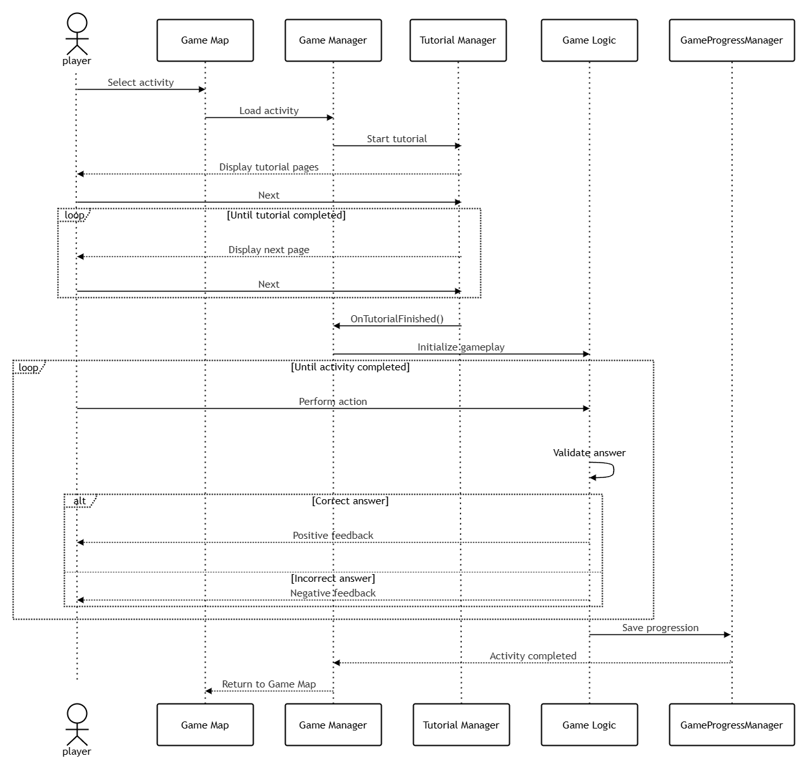
Figure 3.15: Sequence Diagram of the gameplay workflow.
A sequence diagram tracing a full play session, from selecting an activity on the Game Map through the tutorial and gameplay loop to progress being saved and the player returning to the map.

3.4.3 Class Diagram
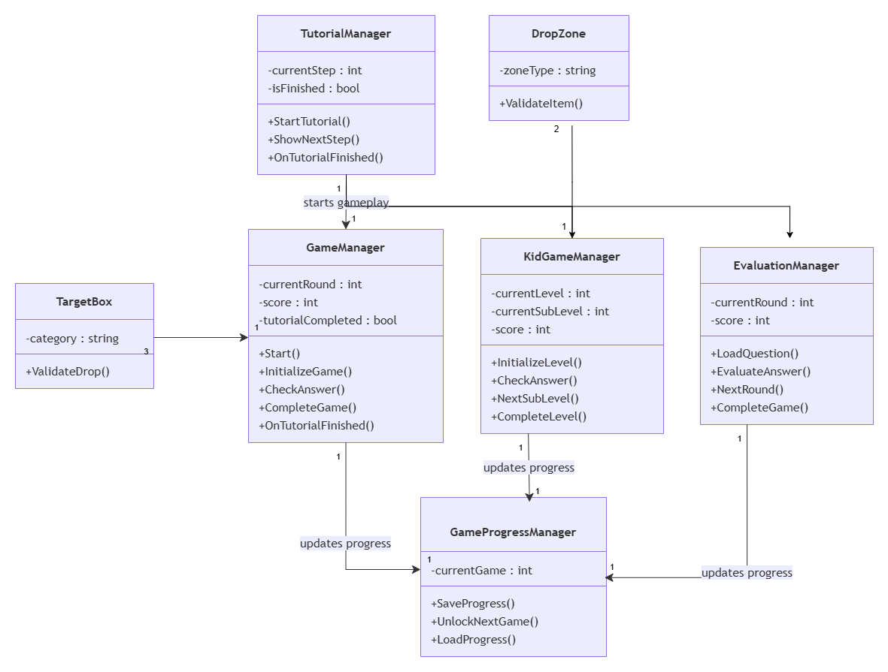
Figure 3.16: Class Diagram of the first three educational modules.
A class diagram showing the relationships between the Tutorial Manager, Drop Zone, Target Box, Game Manager, Kid Game Manager, Evaluation Manager, and Game Progress Manager classes.

Conclusion
This chapter presented the analysis, design, and realization of the first three educational mini-games, covering the concepts of Data Gathering, Data Cleaning, and Image Recognition Evaluation. Together, these modules introduce the initial stages of the Artificial Intelligence learning process through interactive gameplay. The accompanying UML diagrams summarize the common architecture and software interactions implemented within these modules.

Chapter 4

Sprint 4 - 6

Introduction
This chapter presents the analysis, design, and realization of the second group of educational activities developed for the application. These sprints introduce learners to advanced Artificial Intelligence concepts, including Face Detection, AI System Debugging, and Robot Path Planning. Each activity was designed to simplify complex AI concepts through interactive gameplay while maintaining a progressive learning experience. The chapter concludes with the UML diagrams illustrating the common architecture and interactions of these educational modules.

4.1 Sprint 4: Face Detection

4.1.1 Sprint Overview
The objective of this sprint is to introduce learners to the concept of Face Detection, one of the most widely used Computer Vision techniques. The activity demonstrates how Artificial Intelligence systems locate human faces within an image before performing additional recognition or analysis tasks.
During gameplay, the robot places a detection frame on an image containing one or more faces. The learner evaluates whether the detected area is correct and provides feedback accordingly. This interaction helps children understand that AI systems must first detect objects before recognizing or analyzing them.

4.1.2 Sprint Backlog
Table 4.1: Sprint 4 Backlog
No. | Development Tasks | Priority
1 | Design the graphical user interface (GUI) | High
2 | Create face detection scenarios | High
3 | Display AI detection results | High
4 | Implement the learner evaluation mechanism | High
5 | Validate learner responses | High
6 | Manage gameplay rounds | High
7 | Display visual feedback | Medium
8 | Update player progression | High
Lists the development tasks completed during Sprint 4 and their priority.

4.1.3 Activity Workflow
The Face Detection activity introduces the learner to the concept of object localization in Computer Vision. At the beginning of each round, the robot automatically analyzes the displayed image and places a detection square around what it believes to be the face. Depending on its current training score, the robot may place the square correctly, near the face, or far from the target. The learner first evaluates whether the robot's prediction is correct. If the prediction is incorrect, the learner manually adjusts the detection square by dragging it onto the detected face before confirming the correction. The application evaluates the final position of the square, updates the robot's training score, and progressively improves the robot's detection accuracy during subsequent rounds. After all training rounds are completed, the application displays the final result and records the player's progression.

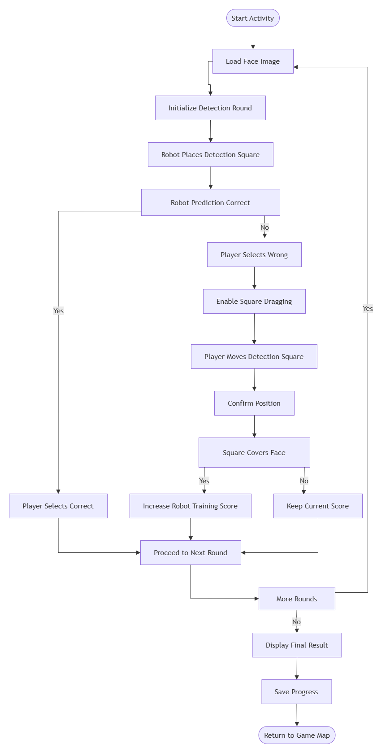
Figure 4.1: Activity Workflow Face Detection
A flowchart of the Face Detection activity, from the robot placing its detection square through the learner's evaluation and correction loop to the final results screen.

4.1.4 Realization
The activity is built around a six-round training loop in which the robot's placement of the detection square is deliberately imprecise at first and improves as an internal training score rises: the first round always places the square far from the face, and later rounds are placed far, near, or exactly on the face depending on score thresholds reached so far. A dishonest verdict, meaning one that disagrees with the true placement, is called out immediately, while a wrong placement the learner correctly catches becomes a hands-on correction step: the learner drags the square onto the face and confirms it, and the training score only increases if the final position lands within a set distance of the true face centre. This progressively improving placement pattern was chosen specifically to give children the experience of watching an AI system get better at a task through repeated correction, rather than presenting a robot that is always right or always wrong. After six rounds the activity records the learner's progress and returns to the Game Map.
The following figures illustrate the main interfaces of the Face Detection activity.
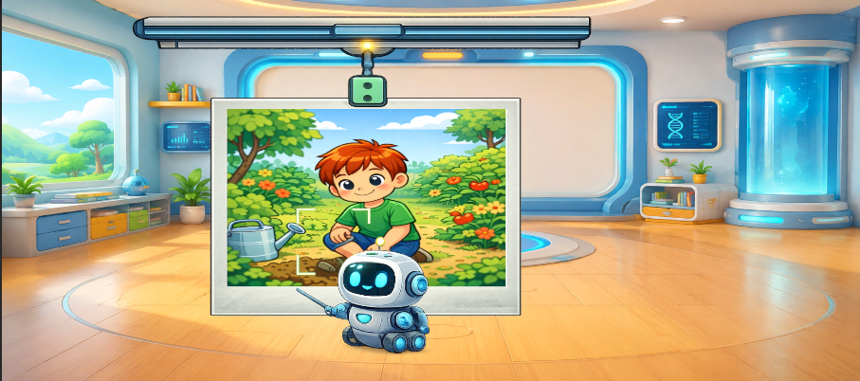
Figure 4.2: Face Detection gameplay interface.
The robot inspecting a photograph, with a highlighted square marking where it believes the face to be.

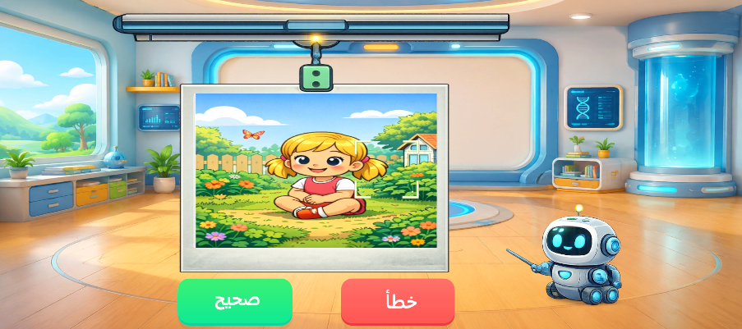

Figure 4.3: Evaluation example.
An example round in which the learner compares the robot's placed square against the photograph before deciding whether it is correct.

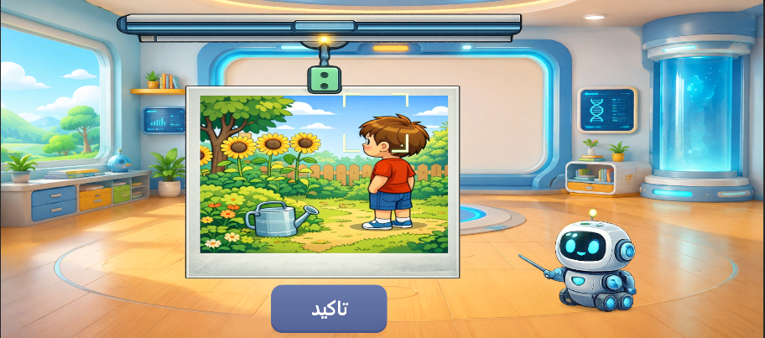

Figure 4.4: Correcting robot’s answer.
The learner dragging the detection square onto the correct position after catching a mistaken placement.

4.2 Sprint 5: AI Agent Debugging

4.2.1 Sprint Overview
The objective of this sprint is to introduce the concept of AI System Debugging. Learners discover that Artificial Intelligence systems may contain faulty components that produce incorrect behavior and therefore need to be identified and corrected.
The activity presents different AI agents, some functioning correctly and others containing errors. Learners must identify the faulty agents and remove them while preserving the correctly functioning ones. This activity develops observation skills while introducing the importance of maintaining reliable AI systems.

4.2.2 Sprint Backlog
Table 4.2: Sprint 5 Backlog
No. | Development Tasks | Priority
1 | Design the graphical user interface (GUI) | High
2 | Create functional and faulty AI agents | High
3 | Implement drag-and-drop interactions | High
4 | Develop the recycle bin mechanism | High
5 | Validate learner actions | High
6 | Display visual feedback | Medium
7 | Manage gameplay rounds | High
8 | Update player progression | High
Lists the development tasks completed during Sprint 5 and their priority.

4.2.3 Activity Workflow
The AI Agent Debugging activity simulates the process of evaluating and correcting an unreliable AI system. At the beginning of each of the six rounds, the application generates a fresh population of agents and randomly labels each one as either well-behaved or faulty, according to the robot's current accuracy: this accuracy starts at 30%, decreases slightly as the rounds progress to keep the challenge consistent, and is always kept between 5% and 95% so that a mix of correct and incorrect agents is always present. The learner inspects the population and drags every faulty agent into a recycle bin while leaving the well-behaved agents untouched. Upon submission, the system compares the learner's choices with the true labels, computing both the proportion of faulty agents correctly removed and the proportion of well-behaved agents removed by mistake, and adjusts the robot's accuracy accordingly. When faulty agents are missed, a guided teaching moment highlights each one in turn before the round is reset, helping the learner recognize the mistake before continuing. After all six rounds are completed, the activity records the learner's progress and returns to the Game Map.

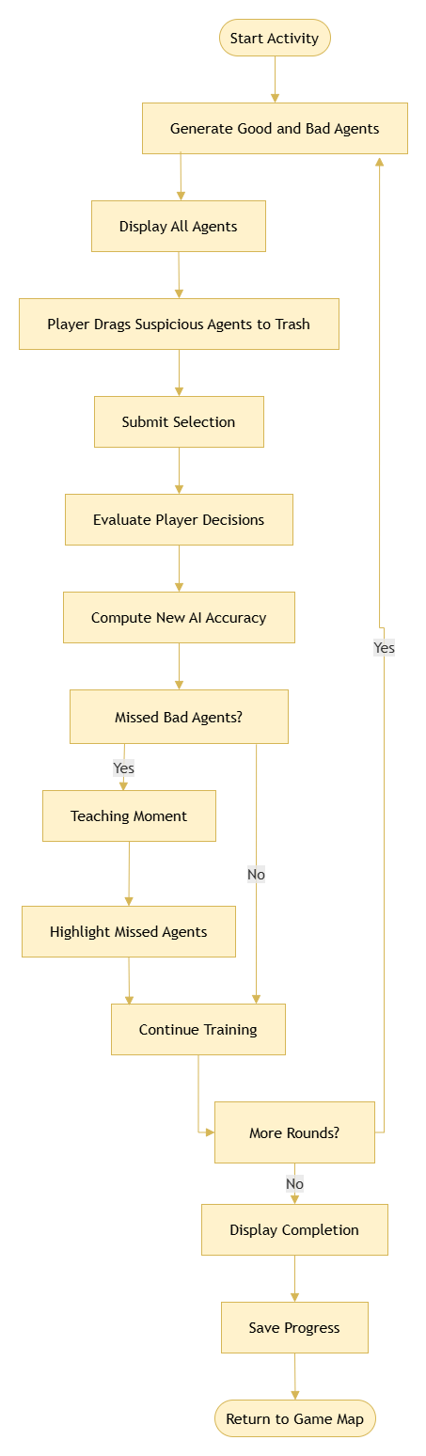
Figure 4.5: Activity Workflow AI Agent Debugging
A flowchart of the AI Agent Debugging activity, showing the round loop in which agents are generated, faulty ones are dragged into the recycle bin, and the robot's accuracy is updated based on the learner's choices.

4.2.4 Realization
The AI Agent Debugging activity was implemented using a drag-and-drop interaction system. Learners identify faulty AI agents and move them into the recycle bin while leaving correctly functioning agents untouched. Quantitatively, each round's accuracy change is computed as 0.20 times the proportion of faulty agents correctly removed, minus 0.15 times the proportion of well-behaved agents removed by mistake. This weights missed faulty agents more heavily than accidental removals, discouraging learners from indiscriminately discarding every agent. Each agent subtly pulses between its base colour and a red or green glow tied to its true label, a soft visual affordance that rewards careful observation without revealing the answer outright, while a shadow placeholder marks its original slot during dragging. Every action is validated immediately to provide real-time feedback and reinforce the learning objective. Once all six rounds are completed successfully, the learner's progression is updated before returning to the Game Map.
The following figures illustrate the main interfaces of the AI Agent Debugging activity.
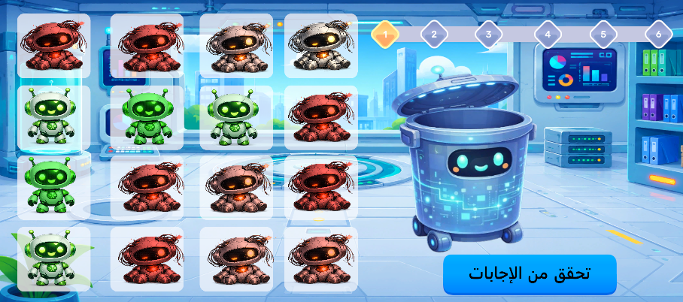
Figure 4.6: AI Agent Debugging gameplay interface.
A grid of AI agents in varying colours to be sorted, a round tracker across the top, and a trash bin used to discard the faulty ones.

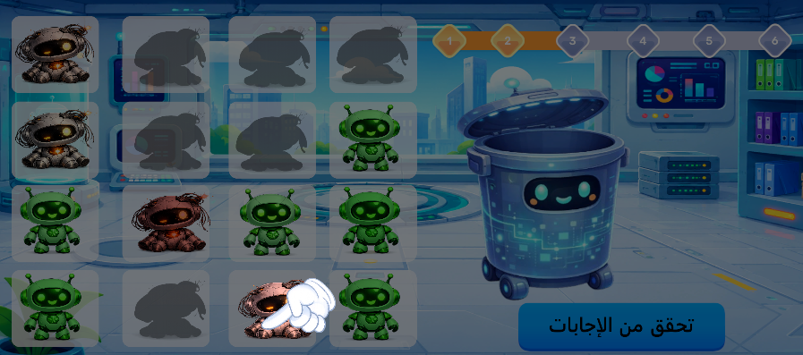

Figure 4.7: Indicate missed agents.
Faulty agents the learner missed are highlighted so they can be recognised before the next round begins.
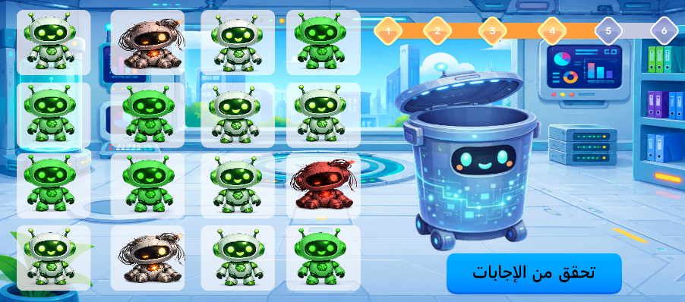

Figure 4.8: Agent Debugging progress
The round tracker after a submission, showing how many of the six rounds have been completed.

4.3 Sprint 6: Robot Path Planning

4.3.1 Sprint Overview
The objective of this sprint is to introduce the concept of Robot Path Planning. This activity demonstrates that intelligent robots must follow an ordered sequence of movement instructions to safely navigate an environment and reach a predefined destination.
The gameplay is based on a maze composed of obstacles and a target location. Learners arrange directional commands to create a valid navigation path before executing the solution. The robot follows the generated sequence, allowing learners to observe how AI systems plan movements to accomplish specific objectives.

4.3.2 Sprint Backlog
Table 4.3: Sprint 6 Backlog
No. | Development Tasks | Priority
1 | Design the graphical user interface (GUI) | High
2 | Create maze layouts | High
3 | Implement robot movement | High
4 | Develop directional command cards | High
5 | Validate navigation sequences | High
6 | Detect collisions with obstacles | High
7 | Manage level progression | High
8 | Return to the Game Map | High
Lists the development tasks completed during Sprint 6 and their priority.

4.3.3 Activity Workflow
The Robot Path Planning activity guides the learner through a maze that must be solved using directional commands. Four difficulty levels are available, each played over two rounds: the maze layout is procedurally generated using a randomized depth-first search algorithm, while the second round of each level reuses a fixed, hand-designed layout to reinforce the concepts learned in the first. The learner builds a movement program either by dragging directional blocks (up, down, left, right) into the program panel or by holding the microphone button and speaking the corresponding command, recognized by the same speech recognition model presented earlier in this report. Once the Play button is pressed, the robot executes the recorded program step by step, sliding in each direction until it reaches the next wall rather than moving one cell at a time. If a move would cross a wall the run stops immediately and an error message is shown; otherwise the robot continues until the full program has executed. Reaching the highlighted goal cell completes the round and advances to the next round or level, while missing it allows the learner to edit the program and try again.

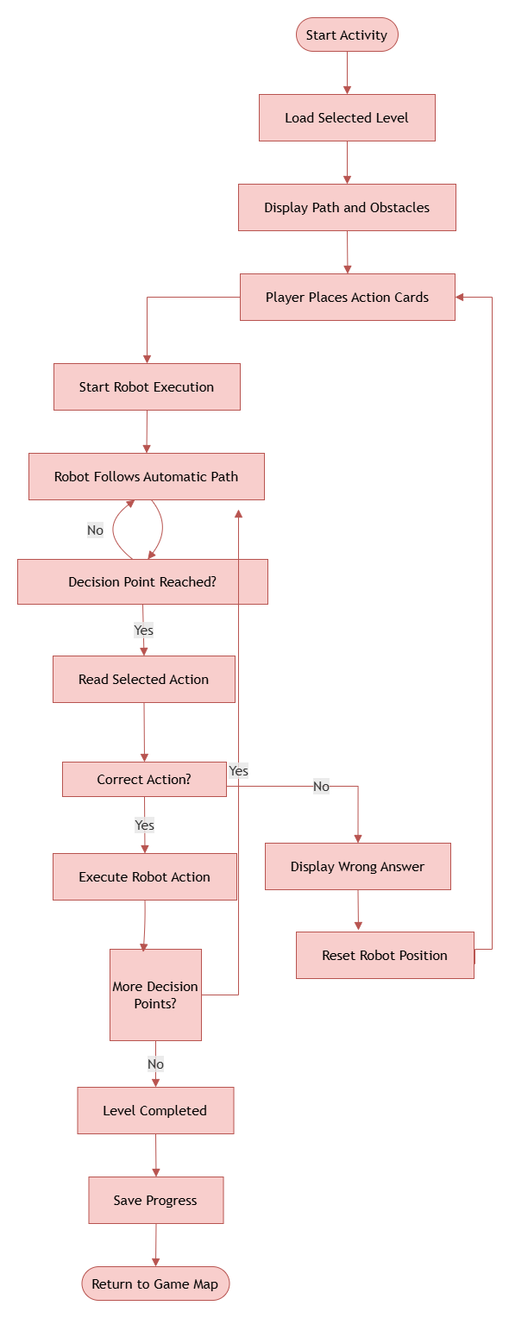
Figure 4.9: Activity Workflow Robot Path Planning
A flowchart of the Robot Path Planning activity, from generating the maze through building and executing the movement program to checking whether the robot reached the goal.

4.3.4 Realization
The Robot Path Planning activity enables learners to construct a sequence of movement instructions that guides the robot through a maze. Movement uses a roll-until-blocked model rather than single-cell steps, a natural fit for a maze built as a grid of walls and open corridors, since it lets a short program of only a few commands cover a full maze without requiring a separate instruction for every individual cell. Across the four levels and two rounds each, eight distinct mazes are presented in total: the first round of every level is procedurally generated so the layout is different each time, while the second round reuses a fixed, hand-designed layout to consolidate what was learned. After executing the generated path, the application validates the solution and immediately displays the result. Successful completion unlocks the next round or level until all levels have been completed, after which the learner returns to the Game Map.
The following figures illustrate the main interfaces of the Robot Path Planning activity.
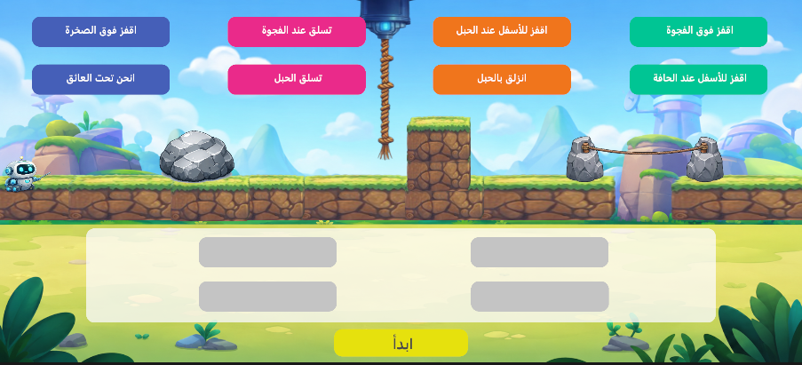
Figure 4.10: Robot Path Planning gameplay interface.
The maze scene with its obstacles, alongside the set of directional action cards and empty program slots the learner fills in before pressing start.

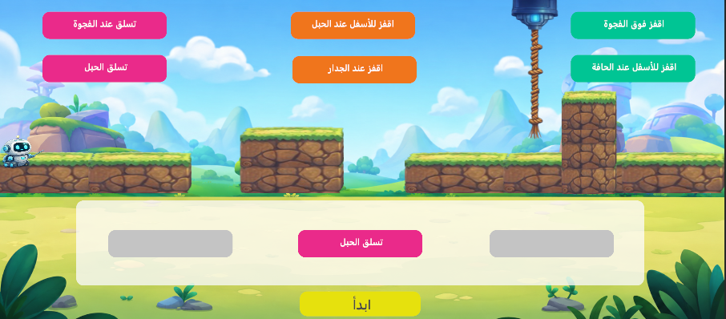

Figure 4.11: Placing Action Cards
The learner filling the empty program slots with directional action cards before running the sequence.

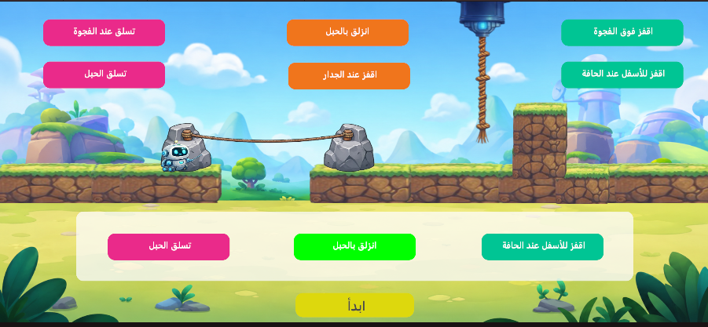

Figure 4.12: Submit selection
The completed program ready to be executed, just before the learner presses play.

4.4 UML Modeling
The following UML diagrams present the common software architecture shared by the Face Detection, AI Agent Debugging, and Robot Path Planning activities. They illustrate the interactions between the learner and the application, the execution flow during gameplay, and the principal software classes responsible for implementing these educational modules.

4.4.1 Use Case Diagram
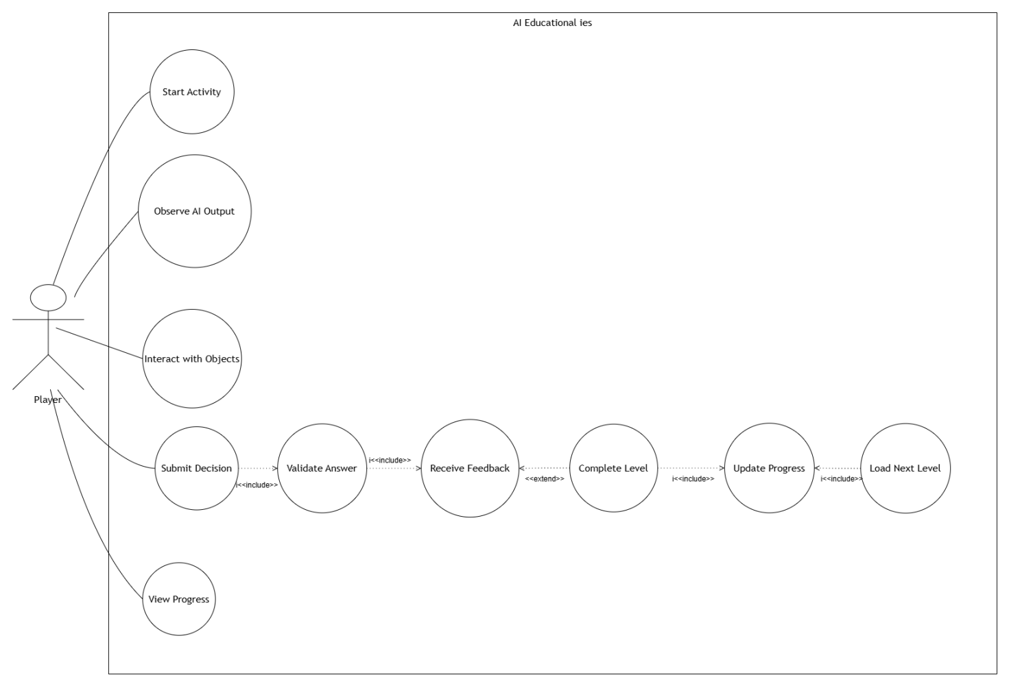
Figure 4.13: Use Case Diagram of the Face Detection, AI Agent Debugging, and Robot Path Planning activities.
The same use case pattern as the earlier chapter, adapted for the Face Detection, AI Agent Debugging, and Robot Path Planning activities.

4.4.2 Sequence Diagram
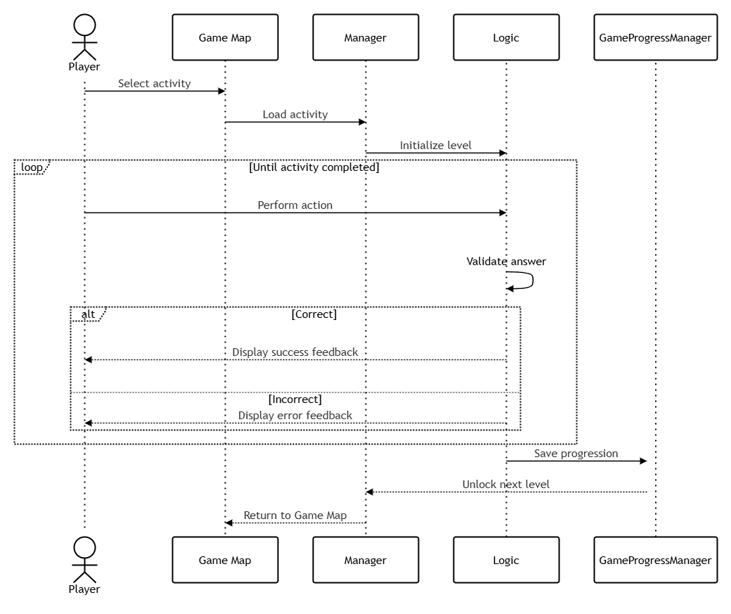
Figure 4.14: Sequence Diagram illustrating the gameplay workflow.
A sequence diagram tracing the shared activity, tutorial, and progress-saving flow used by the Face Detection, AI Agent Debugging, and Robot Path Planning activities.

4.4.3 Class Diagram
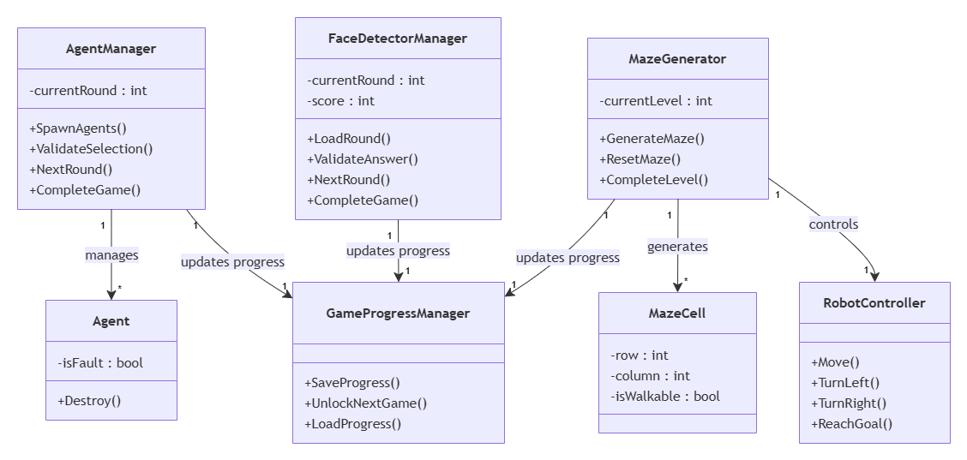
Figure 4.15: Class Diagram of the second group of educational activities.
A class diagram showing the manager and helper classes shared by the second group of activities.

Conclusion
This chapter presented the implementation of three educational activities covering the concepts of Face Detection, AI System Debugging, and Robot Path Planning. Through interactive gameplay, learners discover how AI systems detect human faces, identify faulty system components, and generate navigation paths for autonomous robots. The accompanying UML diagrams summarize the common software architecture and interactions implemented within these modules.

Chapter 5

Sprint 7 - 8

Introduction
This chapter presents the implementation of the final two modules of the educational application. The first sprint introduces the concept of AI Decision Making, allowing learners to understand how intelligent systems select appropriate actions to solve a problem. The second sprint presents the implementation of the Game Map, which serves as the central navigation interface connecting all educational activities while managing player progression and game accessibility. The chapter concludes with the UML diagrams representing the software architecture and interactions of these modules.

5.1 Sprint 7: AI Decision Making

5.1.1 Sprint Overview
The objective of this sprint is to introduce learners to the concept of AI Decision Making. The activity demonstrates that intelligent systems analyze their environment and select the most appropriate action to achieve a specific objective.
The game consists of six progressive levels in which learners arrange action cards representing different robot abilities, such as Jump, Climb, Break Rock, and Use Zipline. After executing the selected sequence, the robot performs each action in order. If the chosen solution is correct, the learner advances to the next level; otherwise, the sequence can be modified and executed again.

5.1.2 Sprint Backlog
Table 5.1: Sprint 7 Backlog
No. | Development Tasks | Priority
1 | Design the graphical user interface (GUI) | High
2 | Create robot action cards | High
3 | Implement drag-and-drop mechanics | High
4 | Develop action slots | High
5 | Validate the action sequence | High
6 | Animate robot actions | High
7 | Manage level progression | High
8 | Update player progression | High
Lists the development tasks completed during Sprint 7 and their priority.

5.1.3 Activity Workflow
The AI Decision Making activity introduces learners to selecting the correct action for a given situation rather than simply moving forward. Each of the six levels defines a fixed path made up of several segments separated by decision points. The robot automatically travels along each segment, and whenever it reaches a decision point it pauses and checks the action card the learner has placed in the corresponding slot beforehand. The available choices include Jump, Climb, Crouch, Break Rock, and Use Zipline, each suited to a specific obstacle. If the placed card matches the action required at that point, the robot performs the corresponding animation and continues toward the next segment; if it does not, the robot shakes to signal the mistake, an error message is displayed, and it returns to the start of the level so the learner can rearrange the cards and try again. Successfully resolving every decision point on the path completes the level and updates the learner's progress.

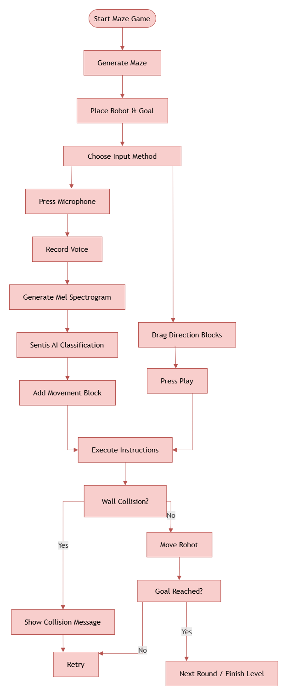
Figure 5.1: Activity Workflow AI Decision Making
A flowchart of the AI Decision Making activity, from travelling along a path segment to checking the action card placed at each decision point and either continuing or returning to the start of the level.

5.1.4 Realization
The AI Decision Making activity was developed to demonstrate how intelligent systems select the appropriate action according to a given situation. Internally, each of the six levels is defined as an ordered list of path segments and decision points rather than a free-form grid: the robot always travels automatically between decision points, so the learner's only choices are which action card belongs at each stop. This is a deliberate contrast with the Robot Path Planning activity, where the learner chooses every movement; here, the emphasis shifts entirely onto selecting the right action for a specific obstacle (Jump, Climb, Crouch, Break Rock, or Use Zipline) rather than on navigation itself. An incorrect card sends the robot back to the very start of the level rather than just the failed segment, reinforcing that the whole planned sequence must be coherent before it is executed. After executing the sequence, the application validates the proposed solution, provides immediate visual feedback, and updates the learner's progression upon successful completion of each level.
The following figures illustrate the main interfaces of the AI Decision Making activity.
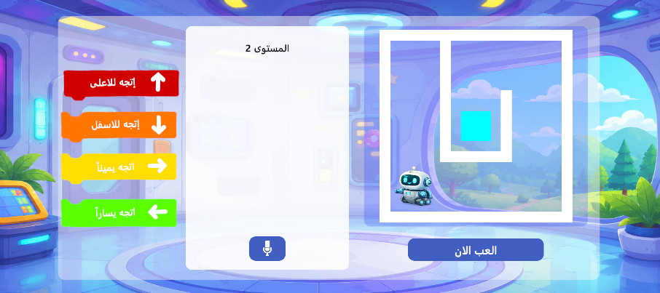
Figure 5.2: AI Decision Making gameplay interface.
The level screen showing the maze view alongside the directional command blocks and the microphone button used for voice input.
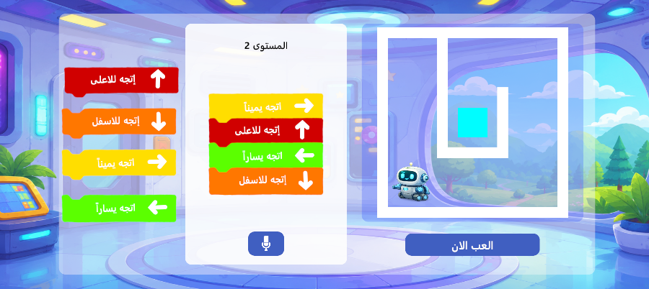

Figure 5.3: Action cards arrangement.
The set of action cards, such as Jump, Climb, and Use Zipline, arranged in the order the learner has chosen to solve the level.

5.2 Sprint 8: Game Map

5.2.1 Sprint Overview
The objective of this sprint is to develop the Game Map, which serves as the central navigation interface of the educational application. It connects all educational activities into a unified learning journey while managing player progression and controlling access to unlocked games.
The Game Map visually represents the learner's progress through an animated drone that moves along a predefined path. As each activity is successfully completed, the next game becomes available, encouraging learners to progress through the Artificial Intelligence learning pipeline in a structured and engaging manner.

5.2.2 Sprint Backlog
Table 5.2: Sprint 8 Backlog
No. | Development Tasks | Priority
1 | Design the Game Map interface | High
2 | Create the navigation path | High
3 | Implement robot movement on the map | High
4 | Develop the game unlocking system | High
5 | Save and load player progression | High
6 | Display locked and unlocked games | Medium
7 | Implement scene navigation | High
8 | Integrate all educational activities | High
Lists the development tasks completed during Sprint 8 and their priority.

5.2.3 Activity Workflow
Sprint 8 focused on integrating the Maze Game into the application's progression system. When the player opens the map, the MapManager retrieves the saved progress using PlayerPrefs, restores the unlocked levels, and places the drone at its latest position.
If the player has just completed a game, a reward panel displaying the completed activity appears. After the player closes the panel, the drone flies toward the next level, the lock animation is played, and the newly unlocked game becomes accessible. The progression is then saved so that it persists between application sessions.

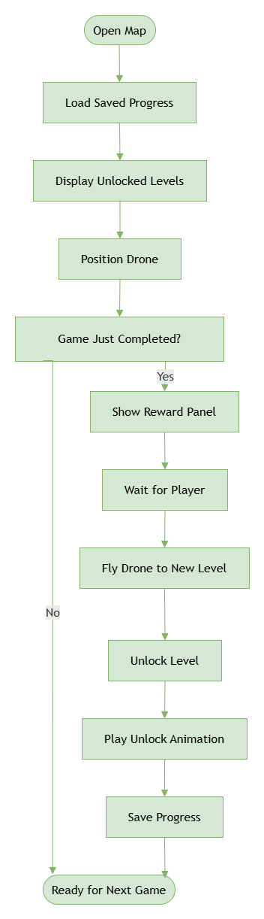
Figure 5.4: Activity Workflow Game Map
A flowchart of the Game Map's progression logic, from restoring the player's saved position to showing the reward panel and unlocking the next activity.

5.2.4 Realization
The Game Map was implemented as the central navigation module of the educational application. Progress is persisted locally through Unity's PlayerPrefs, with a progress-tracking singleton keeping track of each level's status as locked, unlocked, or finished, and the map itself storing which activity the drone last visited so returning players resume exactly where they left off. Finishing an activity's last level triggers a short animated sequence: a reward panel names the completed activity, the drone flies to the next position on the map, and the corresponding lock icon fades out while its level icon transitions from a dimmed grey back to full colour. It is a deliberately celebratory moment intended to make progression feel earned rather than automatic. This centralized system ensures a structured and intuitive learning experience throughout the application.
The following figures illustrate the main interfaces of the Game Map.
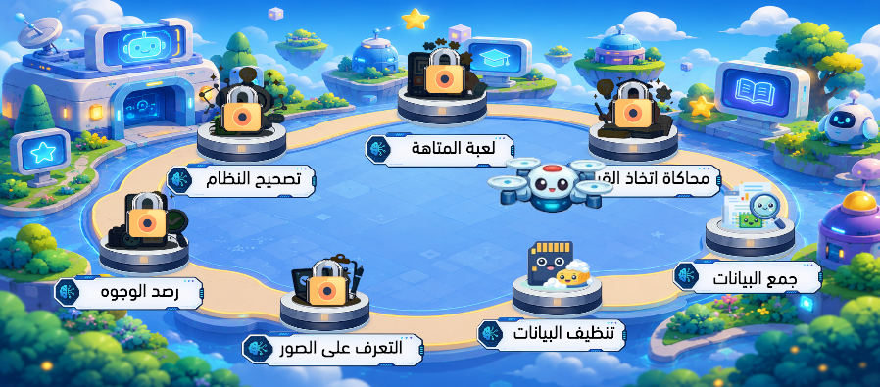
Figure 5.5: Locked and unlocked activities.
The overall Game Map, showing the seven mini-game stops connected along a single path, each marked as locked or unlocked.

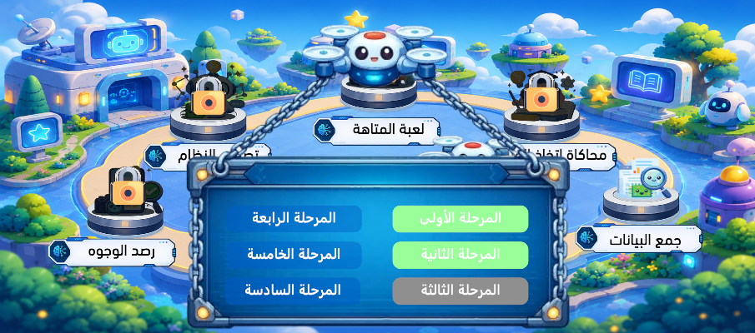

Figure 5.6: Locked and unlocked levels
A closer view of one activity's level selector, distinguishing completed, unlocked, and still-locked levels.

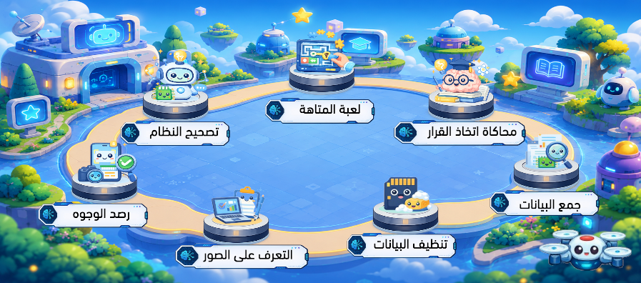

Figure 5.7: Game Map interface
The Game Map interface with the drone positioned at the learner's current activity.

5.3 UML Modeling
The following UML diagrams present the software architecture of the final modules of the educational application. They illustrate the interactions between the learner and the system during the AI Decision Making activity, as well as the management of navigation and progression through the Game Map.

5.3.1 Use Case Diagram
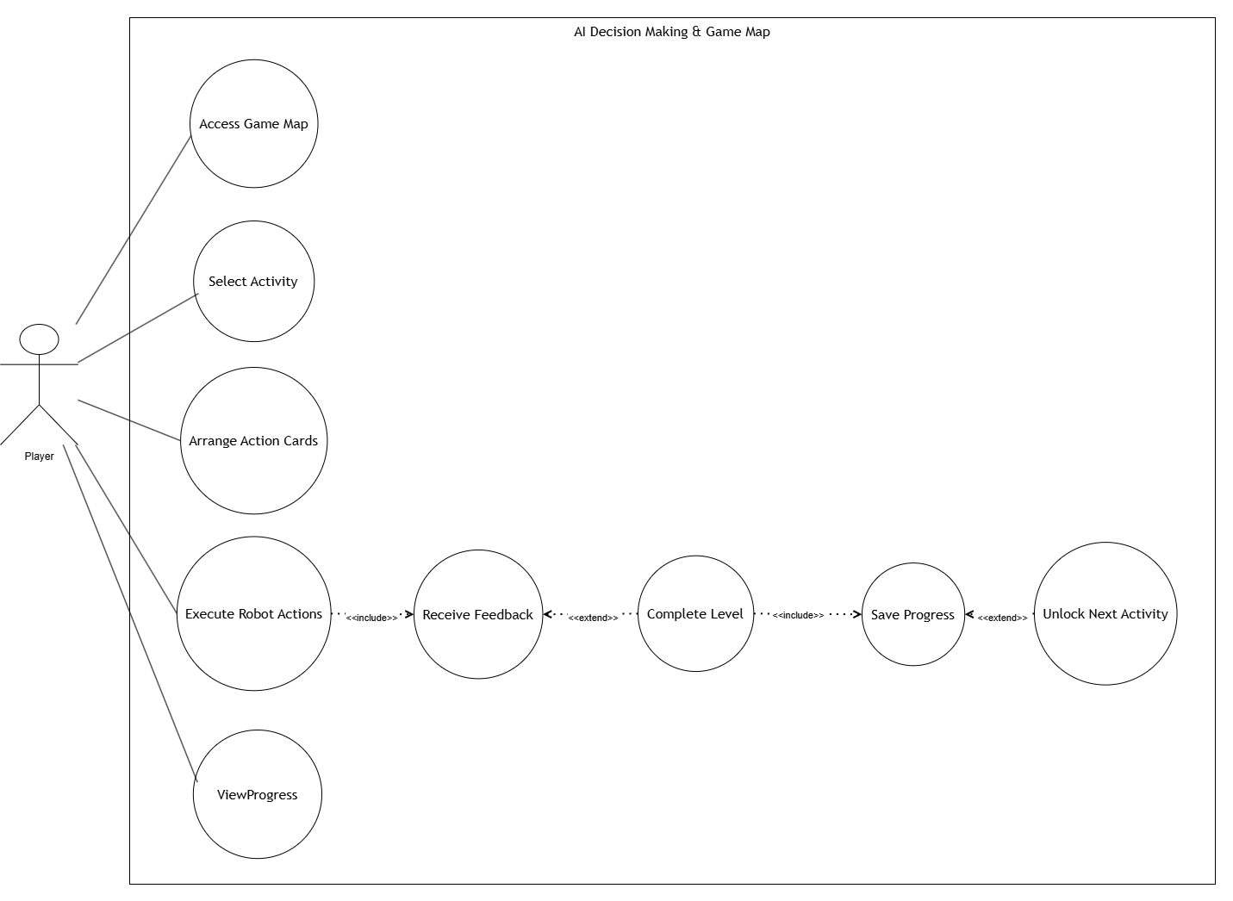
Figure 5.8: Use Case Diagram of the AI Decision Making and Game Map modules.
The same use case pattern as the earlier chapters, adapted for the AI Decision Making activity and the Game Map.

5.3.2 Sequence Diagram
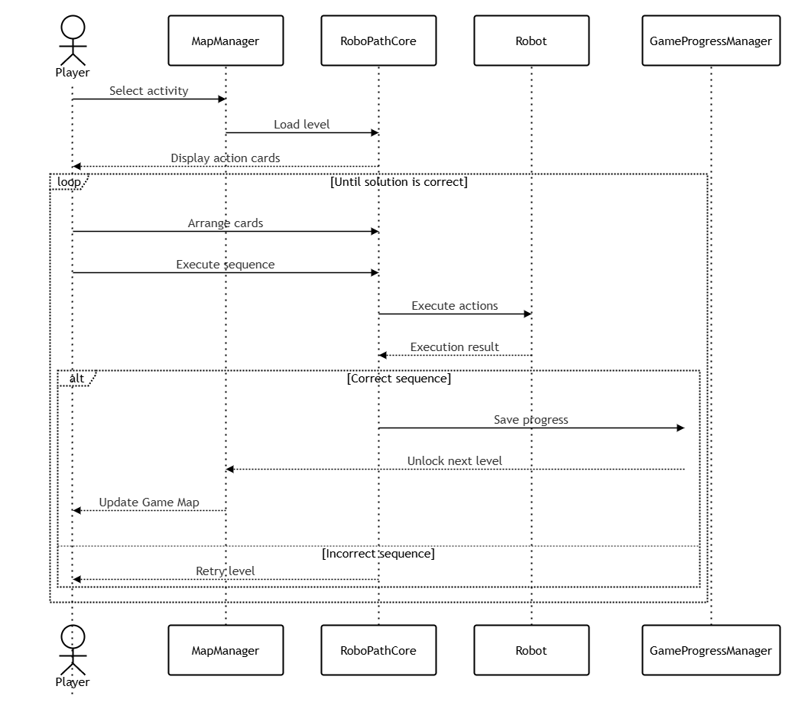
Figure 5.9: Sequence Diagram illustrating the execution flow of the AI Decision Making activity and Game Map navigation.
A sequence diagram tracing the AI Decision Making activity together with the Game Map's navigation and progress-saving flow.

5.3.3 Class Diagram
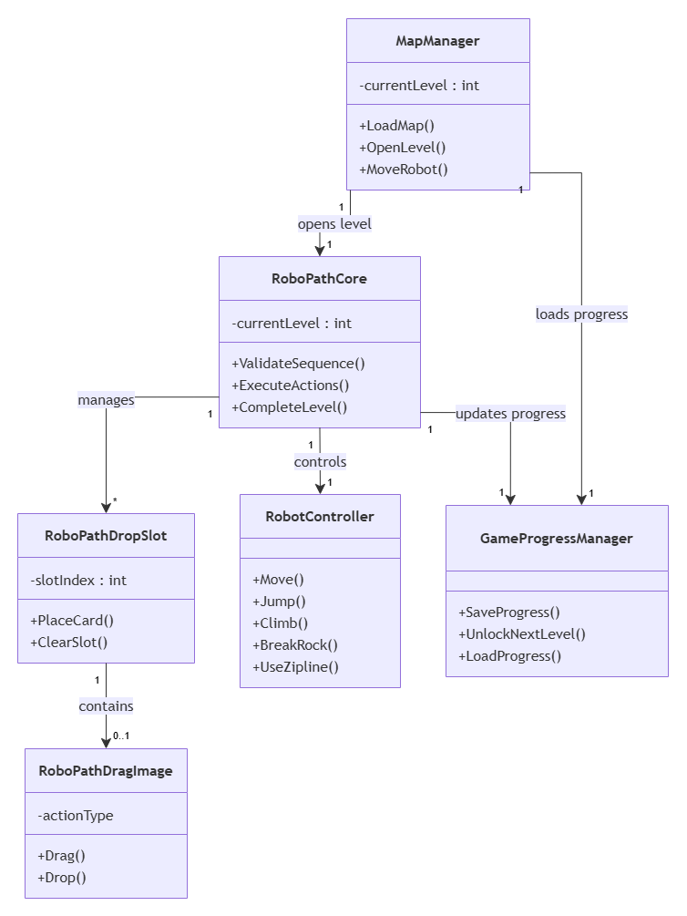
Figure 5.10: Class Diagram of the AI Decision Making and Game Map modules.
A class diagram showing the manager classes shared by the AI Decision Making activity and the Game Map.

Conclusion
This chapter presented the implementation of the final modules of the educational application. The AI Decision Making activity introduced learners to the process of selecting appropriate actions to solve different situations, while the Game Map provided a centralized navigation system that manages learner progression and access to educational activities. Together, these modules complete the educational platform by combining intelligent decision-making concepts with an intuitive progression system, ensuring a coherent and engaging learning experience.

General Conclusion
This Final-Year Project led to the design and development of an educational game that introduces children to the fundamental concepts of Artificial Intelligence through an interactive and engaging learning experience. The proposed solution combines educational content with gamification, enabling learners to progressively discover the different stages of an AI system, including data gathering, data cleaning, image recognition, face detection, intelligent agent behavior, path planning, and decision-making.
From a software engineering perspective, the project was developed following the Agile Scrum methodology, which facilitated effective project planning, continuous development, and incremental delivery of the application. The adoption of modern development tools, including Unity, C#, GitHub, ClickUp, and Visual Studio, contributed to the creation of a robust, modular, and maintainable software architecture.
In addition to the educational mini-games, the project integrates a real Artificial Intelligence component based on speech recognition. A Convolutional Neural Network (CNN) was developed using the PyTorch framework to recognize English voice commands and control the virtual robot within the educational environment. This integration demonstrates the practical application of AI technologies while providing learners with direct interaction with an intelligent system.
The developed game successfully achieves the objectives initially defined by providing an intuitive, interactive, and educational platform adapted to young learners. It offers an innovative approach to introducing Artificial Intelligence concepts while encouraging logical thinking, observation, and problem-solving skills through gameplay.
Despite the satisfactory results obtained, several improvements remain possible. Future work will focus on extending the speech recognition model to support Arabic and French, increasing the diversity of the training dataset using recordings from real users, improving recognition accuracy in noisy environments, and enriching the application with additional educational activities covering more advanced Artificial Intelligence concepts.
In conclusion, this project represents a valuable contribution to the field of educational technology by combining modern software engineering practices with Artificial Intelligence to create an accessible and motivating learning environment. It also provides a solid foundation for future developments aimed at making AI education more interactive, inclusive, and engaging for children.

Webography

[W1] Horizon Education. Official Website. Available at: https://feridaroundtheworld.com/ (Accessed: June 2026).

[W2] Unity Technologies. Unity Documentation. Available at: https://docs.unity3d.com/ (Accessed: June 2026).

[W3] Microsoft. C# Documentation. Available at: https://learn.microsoft.com/dotnet/csharp/ (Accessed: June 2026).

[W4] Microsoft. Visual Studio Documentation. Available at: https://learn.microsoft.com/visualstudio/ (Accessed: June 2026).

[W5] PyTorch Foundation. PyTorch Documentation. Available at: https://pytorch.org/docs/ (Accessed: June 2026).

[W6] Unity Technologies. Unity Sentis Documentation. Available at: https://docs.unity3d.com/Packages/com.unity.sentis/ (Accessed: June 2026).

[W7] Google. Speech Commands Dataset. Available at: https://www.tensorflow.org/datasets/catalog/speech_commands (Accessed: June 2026).

[W8] Git Documentation. Git Reference Manual. Available at: https://git-scm.com/doc (Accessed: June 2026).

[W9] GitHub. GitHub Documentation. Available at: https://docs.github.com/ (Accessed: June 2026).

[W10] ClickUp. Official Documentation. Available at: https://docs.clickup.com/ (Accessed: June 2026).

[W11] Slack. Help Center. Available at: https://slack.com/help (Accessed: June 2026).

[W12] Krita Foundation. Krita User Manual. Available at: https://docs.krita.org/ (Accessed: June 2026).

[W13] Scrum Guides. The Scrum Guide (2020). Available at: https://scrumguides.org/ (Accessed: June 2026).

[W14] Machine Learning for Kids. Available at: https://machinelearningforkids.co.uk/ (Accessed: June 2026).

[W15] Code.org. AI for Oceans. Available at: https://code.org/oceans (Accessed: June 2026).

[W16] Google. Quick, Draw! Available at: https://quickdraw.withgoogle.com/ (Accessed: June 2026).

